SAS-noter
Indhold
SAS-noter 1
SAS language, wiki 1
Overview of syntax[edit] 2
Legal status[edit] 2
See also[edit] 2
Notes[edit] 3
References[edit] 3
External links[edit] 3
SAS Tutorial 3
https://www.tutorialspoint.com/sas/sas_quick_guide.htm 3
Audience 4
Prerequisites 4
SAS - Overview 4
SAS is basically worked on large datasets 5
more than 200 components are available in SAS: 5
Types of SAS Software 6
A SaS Window have 5 parts: Log, Editor, Output, Result=oversigt over {Results}, (File)Explore 7
Libraries in SAS 7
SAS - Environment, download and install 8
Download SAS University Edition 8
Setup virtualization software 9
Quick start virtualization software 10
Download the Zip file 11
Unzip the zip file 12
Loading the virtual machine 13
Power on the virtual machine 14
Starting SAS studio 15
*** The SAS Environment 16
SAS - User Interface 17
SAS Main Window 18
Sas studio Navigation Pane disapeared : når jeg klikker på sas fil kommer det igen 18
Code Autocomplete 18
Program Execution 19
Program Log i Log-fanen 20
Program Result 20
Program Tabs 21
Server Files and Folders 21
/Tasks/Platform/Statistics giver godt overblik over statistic-procedures 22
/Snippets/Data giver godt overblik over data input/output snippets 24
/Program Libraries : indeholder datasæt 25
/File Shortcuts: to access files outside SAS environment 26
*** SAS - Program Structure 27
SAS Program Structure 27
DATA Step 28
Syntax 28
Example 28
Here the string variables have a $ at the end and numeric values are without it 29
PROC Step 29
Syntax 29
Example 29
The OUTPUT Step vel også et proc-step 29
Syntax 29
Example 29
A complete SAS Program, eksempel 29
Program Output 30
***SAS - Basic Syntax 31
SAS Statements 31
SAS Variable Names 31
Variables in SAS represent a column in the SAS data set. 32
Example 32
SAS-konto til web-platform 32
SAS OnDemand for Academics konto 33
*** Course Overview & Objectives, Intro-kursus 33
SAS Program Structure 35
There are 2kinds of steps in SAS programs: DATA and PROC 35
This program has three steps, one DATA step and two PROC steps: 35
TITLE, OPTIONS, and LIBNAM are globale statements: options 37
You can add comments to your code: /* … */ , *command 37
SAS Programming Interfaces 38
Eksempel på program med datafil, udskrift, mean: 39
How to import data into SAS? Upload files 42
Program Files 42
SAS Syntax 43
Exploring SAS Data Sets in SAS Studio 43
Exploring SAS Data Sets Programmatically 44
You can use the PRINT procedure to display the rows of a SAS data set, 44
CONTENTS procedure display metadata for dataset 44
Level 2 Practice: Using Procedures to Validate Data, uni(1)-variate analyse 46
Challenge Practice: Generating Extreme Observations Output 49
The SAS Output Delivery System (ODS) 49
Univariate analyse finder median, quantiler , spredning for een dataserie,min,max 49
Trace giver info om hvert output, er i sig selv et objekt i systemet 49
ods select extremeobs; udvælger specifikt delement 51
**** kursus-link, stadigt aktiv, større kursus 52
https://vle.sas.com/course/view.php?id=11088&section=0 52
https://welcome.oda.sas.com/ sign in page 52
Course Overview & Objectives 52
Opsætning 53
Create the practice files for the course — you only have to do this once. 53
!! Fejl med option locale=da_GL 54
/home/u77510/sasuser.v94/EPG1V2/createdata.sas kan afvikles uden fejl 54
option locale=da_da language=da 56

Har nok 1-2 ugers ’fuldtid’ sammenlagt erfaring med SAS fra gratis onlinekursus, med brug af SAS studio(gratis webplatform) sidste år, SAP-kursus. Efter nytår har jeg genopfrisket mine noter. Med min baggrund med programmering og databehandling mener jeg nu, at have tilstrækkelig forståelse til at udføre meget konkrete, simple opgaver, hjulpet af mine noter og gode eksempler.
Jeg kan godt forstå at SAS er populært indenfor statistisk business analyse. Platformen giver godt overblik over indbyggede vigtige rutiner, så det er meget nemmere at arbejde med end andre programmeringssprog.

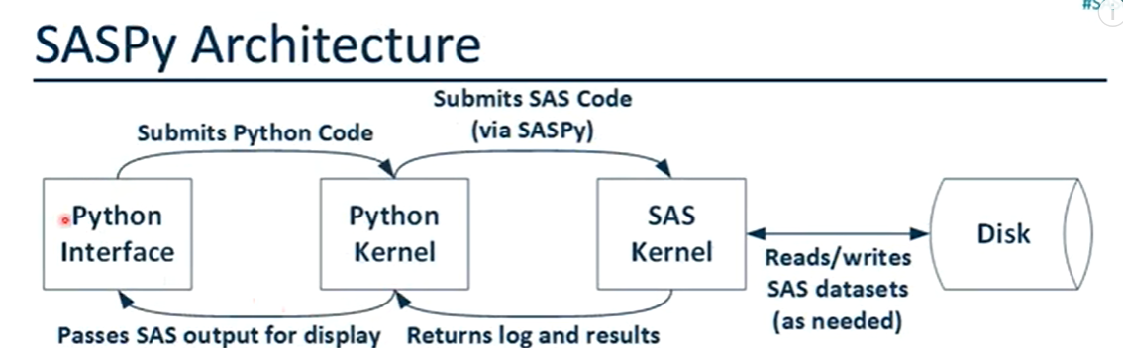
Toggle the table of contents

SAS language, wiki
4 languages
- Article
- Talk
- Read
- Edit
- View history
Tools

From Wikipedia, the free encyclopedia
The SAS language is a computer programming language used for statistical analysis, created by Anthony James Barr at North Carolina State University.^{[1][2]} It can read in data from common spreadsheets and databases and output the results of statistical analyses in tables, graphs, and as RTF, HTML and PDF documents. The SAS language runs under compilers that can be used on Microsoft Windows, Linux, and various other UNIX and mainframe computers. The SAS System and World Programming System (WPS) / Altair SLC are SAS language compilers.

Overview of syntax[edit]
The language is Turing-complete domain specific computer language with many of the attributes of a command language. It is narrowly focused on statistical analysis of data. The language consists of two main types of blocks: DATA blocks that introduce new datasets and PROC blocks that perform procedures on them. A simple example is the following
* COMMENT;
Data TEMP;
input X Y Z;
datalines;
1 2 3
5 6 7
;
run;

PROC PRINT DATA = TEMP;
RUN;
SAS scripts have the .sas extension

Legal status[edit]
SAS is developed and sponsored by the SAS Institute. A competitor, World Programming System / Altair SLC has developed an interpreter and tools that allows execution of the SAS scripts.

See also[edit]
- SAS Institute
- SAS Software
- World Programming System
- List of statistical packages
- Comparison of statistical packages
- SAS Institute Inc v World Programming Ltd

Notes[edit]
  - ^ SAS History, SAS Institute, archived from the original on 2013-10-23, retrieved April 4, 2014
  - ^ Barr & Goodnight, et al. 1976:"The SAS Staff". Attribution of contributions to SAS 72 and SAS 76.

References[edit]
- "Overview of the SAS Language". Department of Animal Science, McGill University. Retrieved 5 October 2013.
- Barr, A. J.; Goodnight, J. H.; Sall, J. P.; Helwig, J. T. (1976), A User's Guide to SAS 76, Raleigh, North Carolina: SAS Institute, Inc., ISBN 0-917382-01-3

External links[edit]
- Learn SAS Programming
- comp.soft-sys.sas at Google Groups.
- UK High Court Judgement on SAS Language
- Sasopedia / SAS Language elements
- SAS whitepaper search
Authority control databases: National |  | - Israel  - United States
 | This programming-language-related article is a stub. You can help Wikipedia by expanding it.
Categories:
- Statistical programming languages
- Programming language topic stubs

SAS Tutorial

https://www.tutorialspoint.com/sas/sas_quick_guide.htm
Øverst på formularen
PDF VersionQuick GuideResourcesJob SearchDiscussion
Nederst på formularen
SAS is a leader in business analytics. Through innovative analytics it caters to business intelligence and data management software and services. SAS transforms data into insight which can give a fresh perspective on business.
Unlike other BI tools available in the market, SAS takes an extensive programming approach to data transformation and analysis rather than a pure drag drop and connect approach. That makes it stand out from the crowd as it gives much finer control over data manipulation. SAS has a very large number of components customized for specific industries and data analysis tasks.

Audience
This tutorial is designed for all those readers who want to read and transform raw data to produce insights for business using SAS. In addition, it will also be quite useful for those readers who would like to become a Data Analyst or Data Scientist.

Prerequisites
Before proceeding with this tutorial, you should have a basic understanding of Computer Programming terminologies. A basic understanding of any of the programming languages will help you in understanding the SAS programming concepts. Familiarity with SQL will help you learn it very fast.

SAS - Overview
SAS stands for Statistical Analysis Software. It was created in the year 1960 by the SAS Institute. From 1st January 1960, SAS was used for data management, business intelligence, Predictive Analysis, Descriptive and Prescriptive Analysis etc. Since then, many new statistical procedures and components were introduced in the software.
With the introduction of JMP (Jump) for statistics SAS took advantage of the Graphical user Interface which was introduced by the Macintosh. Jump is basically used for the applications like Six Sigma, designs, quality control and engineering and scientific analysis.
SAS is platform independent which means you can run SAS on any operating system either Linux or Windows. SAS is driven by SAS programmers who use several sequences of operations on the SAS datasets to make proper reports for data analysis.
Over the years SAS has added numerous solutions to its product portfolio. It has solution for Data Governance, Data Quality, Big Data Analytics, Text Mining, Fraud management, Health science etc. We can safely assume SAS has a solution for every business domain.
To have a glance at the list of products available you can visit SAS Components

SAS is basically worked on large datasets
. With the help of SAS software you can perform various operations on the data like −
- Data Management
- Statistical Analysis
- Report formation with perfect graphics
- Business Planning
- Operations Research and project Management
- Quality Improvement
- Application Development
- Data extraction
- Data transformation
- Data updation and modification
If we talk about the components of SAS then

more than 200 components are available in SAS:
Sr.No. | SAS Component & their Usage
1 | Base SAS  It is a core component which contains data management facility and a programming language for data analysis. It is also the most widely used.
2 | SAS/GRAPH  Create graphs, presentations for better understanding and showcasing the result in a proper format.
3 | SAS/STAT  Perform Statistical analysis with the variance analysis, regression, multivariate analysis, survival analysis, and psychometric analysis, mixed model analysis.
4 | SAS/OR  Operations research.
5 | SAS/ETS  Econometrics and Time Series Analysis.
6 | SAS/IML  CInteractive matrix language.
7 | SAS/AF  Applications facility.
8 | SAS/QC  Quality control.
9 | SAS/INSIGHT  Data mining.
10 | SAS/PH  Clinical trial analysis.
11 | SAS/Enterprise Miner  Data mining.

Types of SAS Software
- Windows or PC SAS
- SAS EG (Enterprise Guide)
- SAS EM (Enterprise Miner i.e. for Predictive Analysis)
- SAS Means
- SAS Stats
Mostly we use Window SAS in organisation as well as in training institute. Some of the organisations use Linux but there is no graphical user interface so you have to write code for every query. But in window SAS there are a lot of utilities available which helps the programmers very much and it also reduces the time of writing the codes as well.

A SaS Window have 5 parts: Log, Editor, Output, Result=oversigt over {Results}, (File)Explore
Sr.No. | SAS Window & their Usage
1 | Log Window  A log window is like an execution window where we can check the execution of the SAS program, tidsforløb, datamængder mv. In this window we can check the errors also. It is very important to check every time the log window after running the program. So that we can have proper understanding about the execution of our program.
2 | Editor Window  Editor Window is that part of SAS where we write all the codes. It is like a notepad.
3 | Output Window  Output window is the result window where we can see the output of our program.
4 | Result Window: It is like an index to all the outputs.  All the programs that we have run in one session of the SAS are listed there and you can open the output by clicking on the output result. But these are mentioned only in one session of the SAS. If we close the software and then open it then the Result Window will be empty.
5 | Explore Window  Here all the libraries listed. You can also browse your system SAS supported files from here.

Libraries in SAS
Libraries are like storage in SAS. You can create a library and save all the similar programs in that library. SAS provides you the facility to create multiple libraries. A SAS library is only 8 characters long.
There are two types of libraries are available in SAS −
Sr.No. | SAS Window & their Usage
1 | Temporary or Work Library  This is the by default library of SAS. All the programs that we create are stored in this work library if we do not assign any other library to them. You can check this work library in the Explore Window. If you create a SAS program and have not assign any permanent library to it then if you end the session after that again you start the software then this program will not be in the work library. Because it will only be there in Work library as long as the session goes ones.
2 | Permanent Library  These are the permanent libraries of SAS. We can create a new SAS library by using SAS utilities or by writing the codes in the editor window. These libraries are named as permanent because if we create a program in SAS and save it in these permanent libraries then these will be available as long as we want them.

SAS - Environment, download and install
SAS Institute Inc. has released a free SAS University Edition which is good enough for learning SAS programming. It provides all the features that you need to learn in BASE SAS programming which in turn enables you to learn any other SAS component.
The process of downloading and installing SAS University Edition is very straight forward. It is available as a virtual machine which needs to run on a virtual environment. You need to have virtualization software already installed in your PC before you can run the SAS software. In this tutorial we will be using VMware. Below are the details of the steps to download, setup the SAS environment and verify the installation.

Download SAS University Edition
SAS University Edition is available for download at the URL SAS University Edition. Please scroll down to read the system requirements before you begin the download. The following screen appears on visiting this URL.
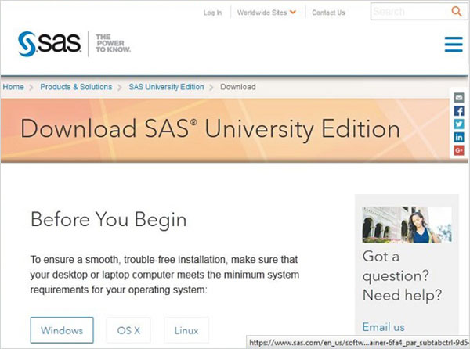

Setup virtualization software
Scroll down on the same page to locate the installation stpe-1. This step provides the links to get the virtualization software that suits you. In case you already have any one of these softwares installed in your system, you can skip this step.
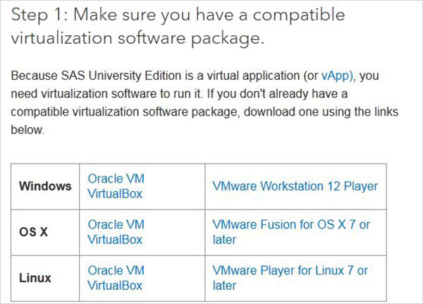

Quick start virtualization software
In case you are completely new to virtualization environment, you can familiarize yourself with it by going through the following guides and videos available as step-2. Again you can skip this step in case you are already familiar.
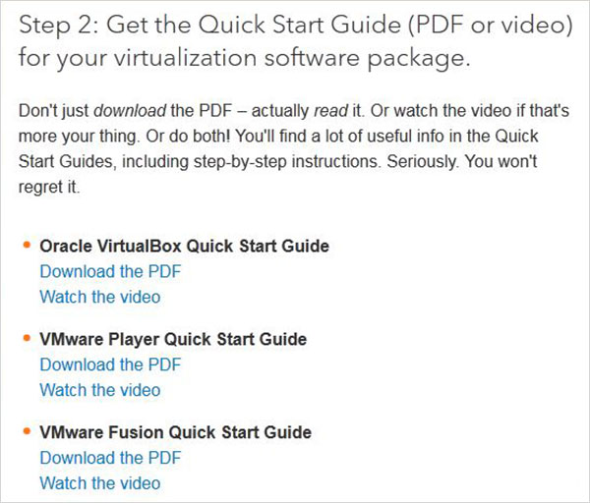

Download the Zip file
In step-3 you can choose the appropriate version of the SAS University Edition compatible with the virtualization environment you have. It downloads as a zip file with name similar to unvbasicvapp__9411005__vmx__en__sp0__1.zip
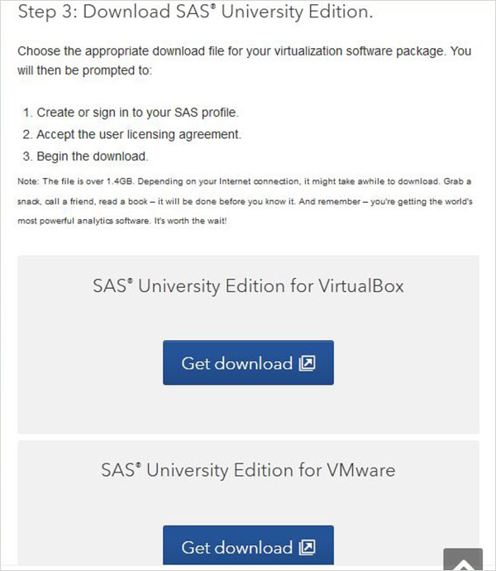

Unzip the zip file
The zip file above needs to be unzipped and stored in an appropriate directory. In our case we have chosen the VMware zip file which shows the following files after unzipping.
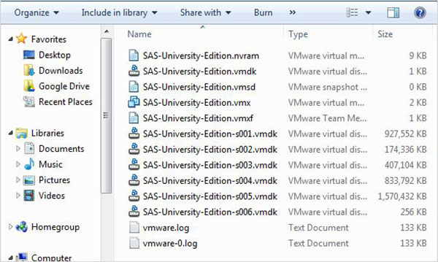

Loading the virtual machine
Start the VMware player (or workstation) and open the file which ends with an extension .vmx. The below screen appears. Please notice the basic settings like memory and hard disk space allocated to the vm.
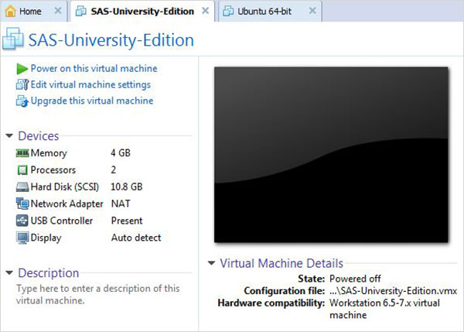

Power on the virtual machine
Click the Power on this virtual machine alongside the green arrow mark to start the virtual machine. The following screen appears.
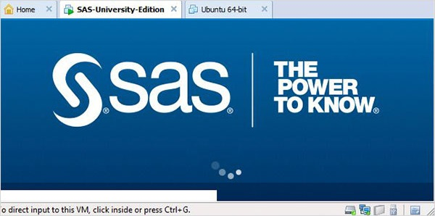
The below screen appears when the SAS vm is in the state of loading after which the running vm gives a prompt to go to a URL location which will open the SAS environment.
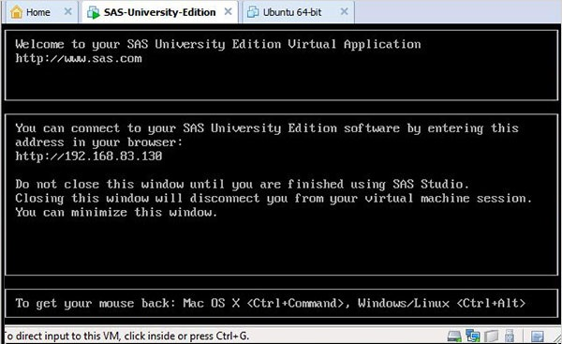

Starting SAS studio
Open a new browser tab and load the above URL (which differs from one PC to another). The below screen appears indicating the SAS environment is ready.
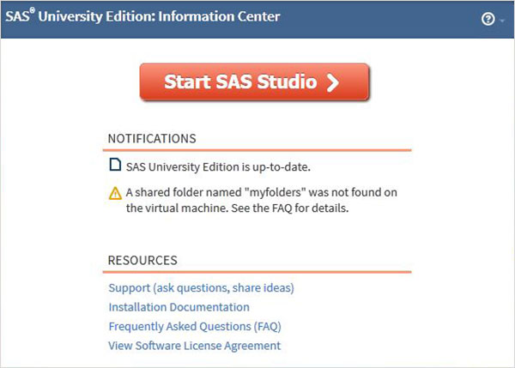

*** The SAS Environment
On clicking the Start SAS Studio we get the SAS environment which by default opens in the visual programmer mode as shown below.
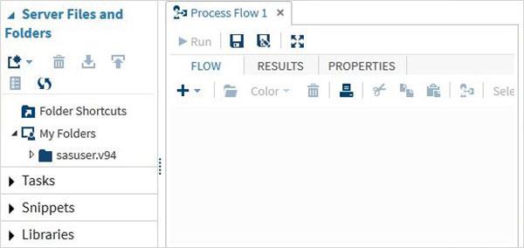
We can also change it to SAS programmer mode by clicking on the drop down.
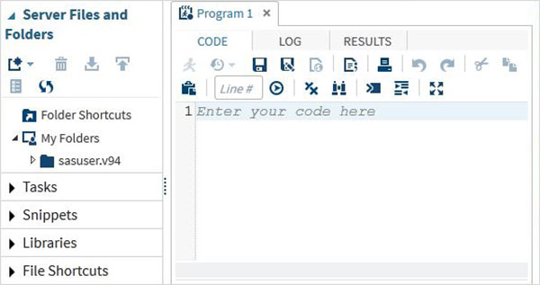
Now we are ready to write SAS Programs.

SAS - User Interface
SAS Programs are created using a user interface known as SAS Studio.
Below is a description of various windows and their usage.

SAS Main Window
This is the window you see on entering the SAS environment. In the left is the Navigation Paneused to navigate various programming features. In the right is the Work Area which is used for writing the code and executing it.

Sas studio Navigation Pane disapeared : når jeg klikker på sas fil kommer det igen
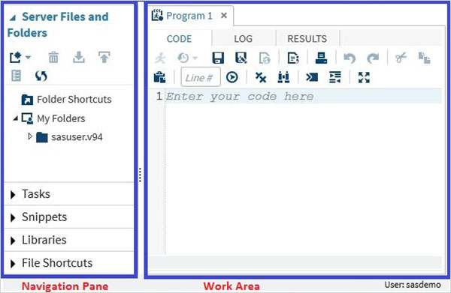

Code Autocomplete
This is a very powerful feature which helps getting the correct syntax of SAS keywords as well as provides link to the documentation for that keyword.
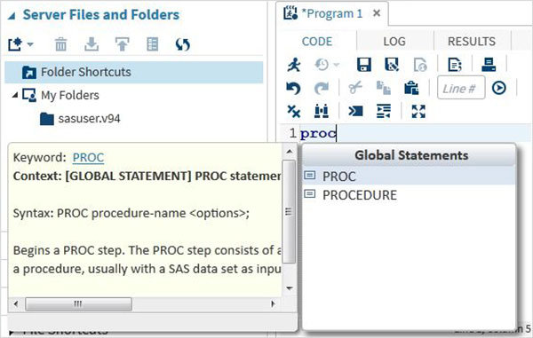

Program Execution
The execution of code is done by pressing the run icon, which is the first icon from left or the F3 button.
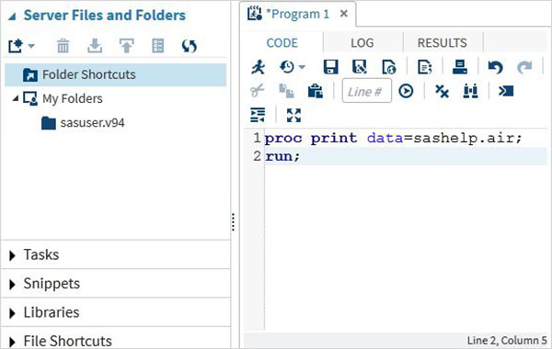

Program Log i Log-fanen
The log of the executed code is available under the Log tab. It describes the errors, warnings or notes about the program’s execution. This is the window where you get all the clues to troubleshoot your code.
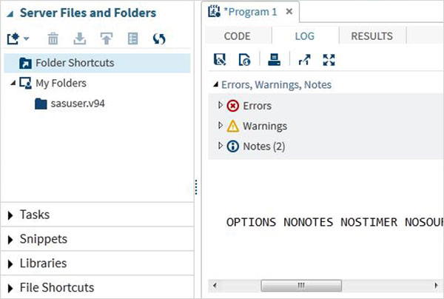

Program Result
The result of the code execution is seen in the RESULTS tab. By default they are formatted as html tables.
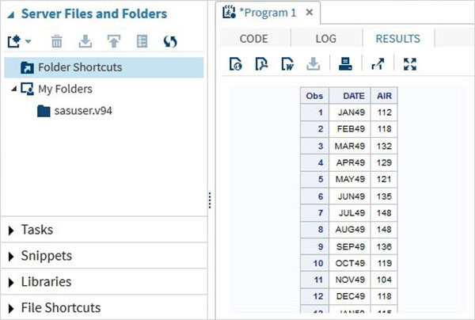

Program Tabs
The Navigation Area contains features to create and manage programs. It also provides the pre-built functionalities to be used with your program.

Server Files and Folders
Under this tab we can create additional programs, import data to be analyzed and query the existing data. It can also be used to create folder shortcuts.
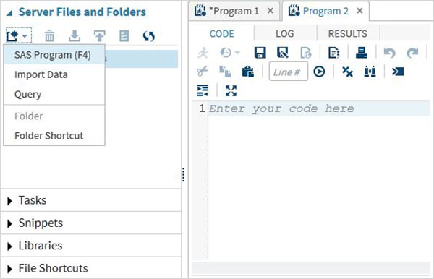
Tasks
The Tasks tab provides features to use in-built SAS programs by supplying only the input variables. For example under the statistics folder you can find a SAS program to do linear regression by only supplying the SAS data set name and variable names.

/Tasks/Platform/Statistics giver godt overblik over statistic-procedures
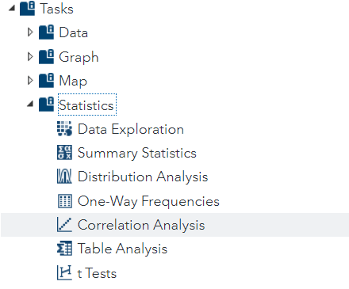
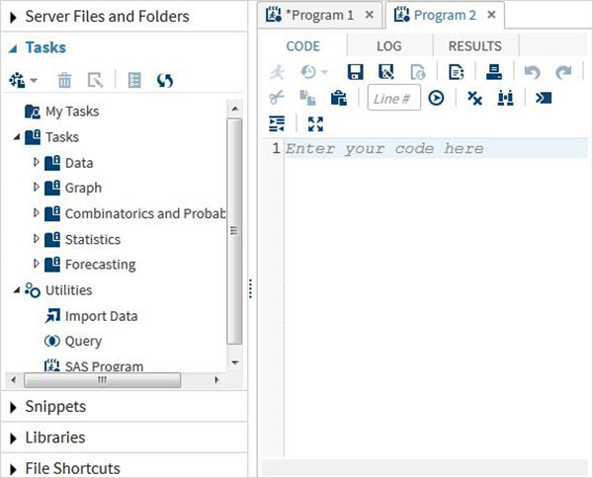
Snippets
The snippets tab provides features to write SAS Macro and generate files from the existing data set

/Snippets/Data giver godt overblik over data input/output snippets

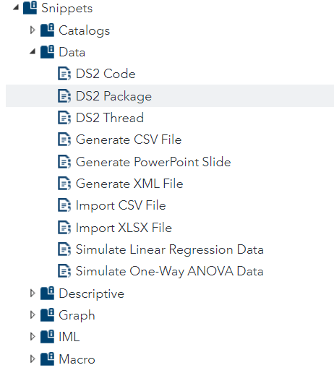
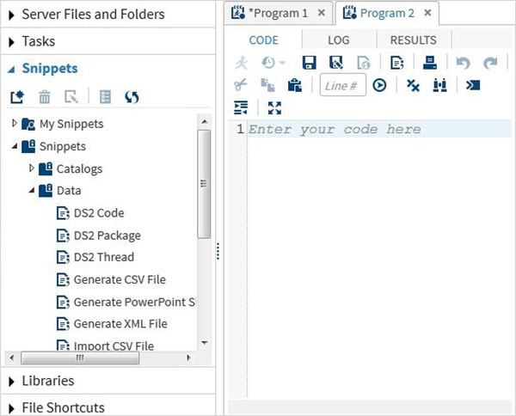

/Program Libraries : indeholder datasæt
SAS stores the datasets in SAS libraries. The temporary library is available only for a single session and it is named as WORK. But the permanent libraries are available always.
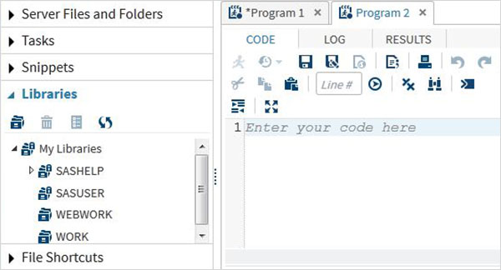

/File Shortcuts: to access files outside SAS environment
This tab is used to access files which are stored outside the SAS environment. The shortcuts to such files are stored under this tab.
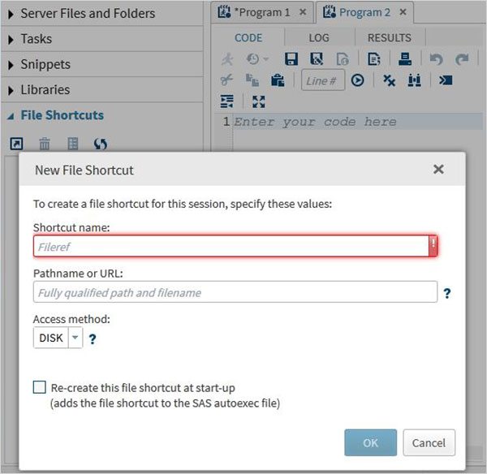

*** SAS - Program Structure
The SAS Programming involves first creating/reading the data sets into the memory and then doing the analysis on this data. We need to understand the flow in which a program is written to achieve this.

SAS Program Structure
The below diagram shows the steps to be written in the given sequence to create a SAS Program.
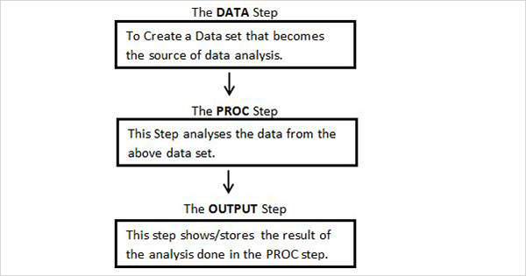
Every SAS program must have all these steps to complete reading the input data, analysing the data and giving the output of the analysis. Also the RUN statement at the end of each step is required to complete the execution of that step.

DATA Step
This step involves loading the required data set into SAS memory and identifying the variables (also called columns) of the data set. It also captures the records (also called observations or subjects, rows), ligesom R-DataFrame. The syntax for DATA statement is as below.

Syntax
DATA data_set_name; #Name the data set, output
INPUT var1,var2,var3; #Define the variables in this data set.
NEW_VAR; #Create new variables.
LABEL; #Assign labels to variables.
DATALINES; #Enter the data.
RUN;

Example
The below example shows a simple case of naming the data set, defining the variables, creating new variables and entering the data.

Here the string variables have a $ at the end and numeric values are without it

PROC Step
This step involves invoking a SAS built-in procedure to analyse the data.

Syntax
PROC procedure_name options; #The name of the proc.
RUN;

Example
The below example shows using the MEANS procedure to print the mean values of the numeric variables in the data set.
PROC MEANS;
RUN;

The OUTPUT Step vel også et proc-step
The data from the data sets can be displayed with conditional output statements.

Syntax
PROC PRINT DATA = data_set;
OPTIONS;
RUN;

Example
The below example shows using the where clause in the output to produce only few records from the data set.
PROC PRINT DATA = TEMP;
WHERE SALARY > 700;
RUN;

A complete SAS Program, eksempel
Below is the complete code for each of the above steps.
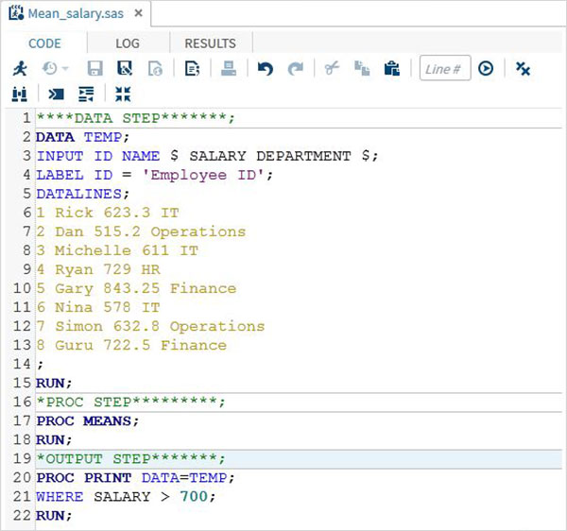

Program Output
The output from above code is seen in the RESULTS tab.
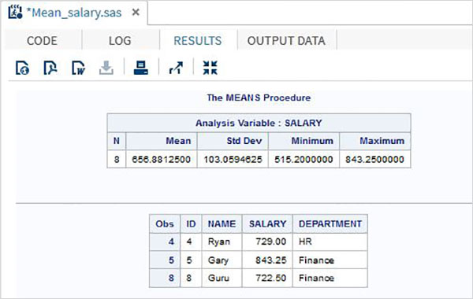

***SAS - Basic Syntax
Like any other programming language, the SAS language has its own rules of syntax to create the SAS programs.
The three components of any SAS program - Statements, Variables and Data sets follow the below rules on Syntax.

SAS Statements
- Statements can start anywhere and end anywhere. A semicolon at the end of the last line marks the end of the statement.
- Many SAS statements can be on the same line, with each statement ending with a semicolon.
- Space can be used to separate the components in a SAS program statement.
- SAS keywords are not case sensitive.
- Every SAS program must end with a RUN statement.

SAS Variable Names

Variables in SAS represent a column in the SAS data set.
The variable names follow the below rules.
- It can be maximum 32 characters long.
- It can not include blanks.
- It must start with the letters A through Z (not case sensitive) or an underscore (_).
- Can include numbers but not as the first character.
- Variable names are case insensitive.

Example
# Valid Variable Names
REVENUE_YEAR
MaxVal
_Length

# Invalid variable Names
Miles Per Liter #contains Space.
RainfFall% # contains apecial character other than underscore.
90_high # Starts with a number.

Kickstart Your Career
Get certified by completing

SAS-konto til web-platform
!Hund2020…
bjarnephys@yahoo.dk
du bruge e-mailadresse og password til at logge p

https://vle.sas.com/course/view.php?id=11088 kursus, Connection failed: MySQL server has gone away, 1år siden, ny konto nødvendig!
https://welcome.oda.sas.com/

/home/u77510/sasuser.v94 på server https://odamid-euw1.oda.sas.com/

SAS OnDemand for Academics konto
Welcome to SAS(r) OnDemand for Academics. Your user ID is:

u77510

You can use either this user ID or your email address (bjarnephys@yahoo.dk), along with your SAS Profile password, to sign in to SAS OnDemand for Academics:
https://welcome.oda.sas.com

After signing in, you can:

* Access SAS Studio software.
* Register a course and share course information with students.
* Review reference and support information. This information is also available from the support site: https://support.sas.com/ondemand

Regards,
The SAS OnDemand for Academics Team

*** Course Overview & Objectives, Intro-kursus
This course is for users who want to learn how to write SAS programs to access, explore, prepare, and analyze data. In this course, you will learn how to write SAS code to handle the most common data processing tasks. We'll use the following steps for teaching you the fundamentals of the SAS programming language:
- Essentials of SAS Programming
Use SAS Studio and SAS Enterprise Guide to write and submit SAS programs.
- Accessing data or reading it with a program
Access SAS, Microsoft Excel, and text data.
- Exploring the data to see what's there and what you might need to add or change
Explore and validate data.
- Preparing the data for analysis
Prepare data by subsetting rows and computing new columns.
- Analyzing and reporting on the data
Analyze and report on data.
- Export results to various report and data formats
Export data and results to Excel, PDF, and other formats.
Using SAS OnDemand for Academics.
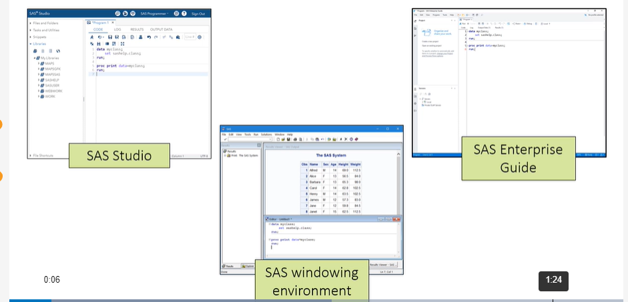

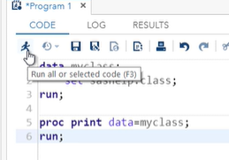

SAS Program Structure
Let's start by taking a high-level look at the structure of SAS programs. A SAS program consists of a sequence of steps. Each step in the program performs a specific task.

There are 2 kinds of steps in SAS programs: DATA and PROC
A SAS program can contain any combination of DATA steps and PROC steps depending on the tasks you want to perform. DATA and PROC steps get their name from the keyword that begins the first statement in the step: DATA or PROC. Most steps end with a RUN statement, and a few PROC steps end with a QUIT statement. If you don't use a RUN statement at the end of a step, the beginning of a new DATA or PROC step signals the end of the previous step.

This program has three steps, one DATA step and two PROC steps:

data myclass; # output fra dette step, til videre steps
set sashelp.class; # input, class filen fra /sashelp
heightcm=height*2.54;
run; // se ½siden nedenfor

proc print data=myclass;
run;

proc means data=myclass;
var age heightcm;
run;
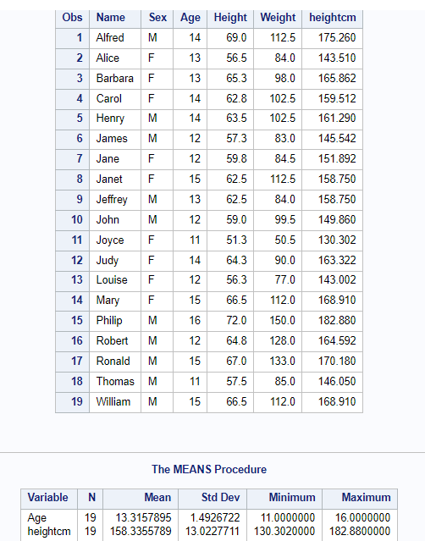
A DATA step generally reads data from an input source, processes it, and creates a SAS table. A DATA step might also filter rows, compute new columns, join tables, and perform other data manipulations. In this program, the DATA step is creating an output table, vel sashelp.class, and adding a new column.
A PROC, or procedure, step processes a SAS table in a specific, predefined way. SAS has dozens of procedures that generate reports and graphs, manage data, or perform complex statistical analyses. In this program, the PROC PRINT step generates a list of all the rows and columns in the data, and the PROC MEANS step calculates basic summary statistics.
Now lets zoom in a bit and look at the structure of steps. Each step consists of a sequence of statements, and most statements start with a keyword that's part of the SAS language.
This DATA step has four statements: a DATA statement, a SET statement, an assignment statement, and a RUN statement. DATA, SET, and RUN are keywords. The assignment statement creates a new column and it doesn't start with a keyword.
data myclass; *navngivning af sættet ,* er comment
set sashelp.class; *må være datasættet
heightcm=height*2.54;
run;
heightcm en variable, og variable er kolonner i tabeller, derfor tilføjes den som kolonne i myclass tabellen
The first PROC step has 2 statements: the PROC PRINT statement and the RUN statement.
proc print data=myclass;
run;
The last PROC step has three statements: the PROC MEANS statement, the VAR statement, and a RUN statement.
proc means data=myclass;
var age heightcm;
run;
The really important thing to remember here is that all statements must end with a semicolon.

TITLE, OPTIONS, and LIBNAM are globale statements: options
In addition to DATA and PROC steps, a SAS program can also contain global statements such as the TITLE, OPTIONS, and LIBNAME statments. These statements can be outside DATA and PROC steps, and they typically define some option or setting for the SAS session. Global statements do not need a RUN statement after them.

Now let's talk about some details of SAS syntax. These two programs have exactly the same code.

data myclass;set sashelp.class;run;
proc print data=myclass;run;

------------------------------------------

data myclass;
set sashelp.class;
run;

proc print data=myclass;
run;
The first DATA and PROC steps have no line breaks in the steps. The second DATA and PROC steps have line breaks and indentation. Spacing doesn't matter to SAS, but it does matter to people reading your code. It's a good idea to use spaces and extra lines to make your program easy to read and understand. There are also tools in your program editor that format code for you.
You can type unquoted values, such as columns, table names, or keywords in any case.

You can add comments to your code: /* … */ , *command
that are ignored when the program executes. You can use these comments to document your code or to suppress a portion of your code from executing. To comment out a single statement ending in a semicolon you add an asterisk at the beginning of the statement. To comment out multiple lines of code, you add /* at the beginning and */ at the end of the text you want to comment out.

/* students under 13 years old */

data under13;
set sashelp.class;
where Age<13;
*drop Height Weight;
run;

SAS Programming Interfaces
Let's take a look at a program and examine some of the rules we just discussed about SAS syntax.
- Open the p101d02.sas program from the demos folder. The program is not spaced well. It has multiple statements on a single line and the indention of certain statements is inconsistent.
- data mycars; set sashelp.cars;
- AvgMPG=mean(mpg_city, mpg_highway);
- run;
- title "Cars with Average MPG Over 35";
- proc print data=mycars;
- var make model type avgmpg;
- where AvgMPG > 35; run;
- title "Average MPG by Car Type";
- proc means data=mycars
- mean min max maxdec=1;
- var avgmpg;class type;
RUN;TITLE;

- Submit the program to see if it runs correctly. The program runs without any warnings or errors.
- Go back to the code. Click the Format Code button or right-click in the program and select Format Code.
- Next we'll add some comments to the code. Add the following text before the DATA statement: Program created by < your-name > . Next, highlight the text and press Ctrl and forward slash (/) to automatically surround it with the comment symbols, /* and */.
- Although you haven't learned about the syntax yet, there is a WHERE statement in the code that is subsetting, filtrering, the data for AvgMPG greater than 35, and there is a corresponding title that indicates that the data has been subset. Comment out the first TITLE statement and the WHERE statement in PROC PRINT by putting an asterisk in front of each statement.
- Run the code and verify that there is no title in the report and the AvgMPG column has values less than 35.
Solution code:

Eksempel på program med datafil, udskrift, mean:
/*Program created by, MPG=mile per Gallon benzin, intet output fra del1 */
data mycars;
set sashelp.cars;
AvgMPG=mean(mpg_city, mpg_highway); * for hver bil findes de to værdier, vi bruger middelværdien
run;

*title "Cars with Average MPG Over 35"; *title for flg table:

proc print data=mycars;
var make model type avgmpg; * 4 variable udskrives
*where AvgMPG > 35; #subsetting, nu commented out, så nu inaktiv, tab1
run;

title "Average MPG by Car Type"; *tab2

proc means data=mycars
mean min max maxdec=1;
var avgmpg; #kun denne variable er input til mean, min, max
class type;
run;

title;
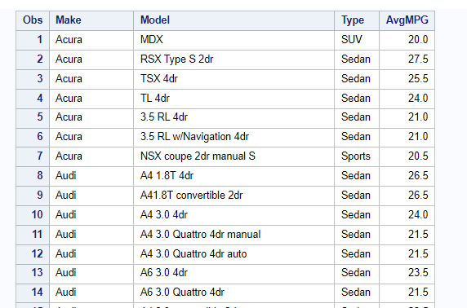tab1
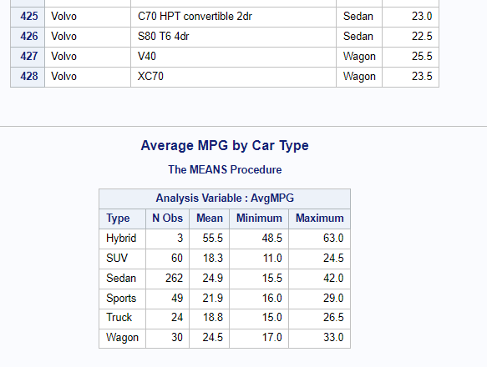tab2

data readin; *laver readin datasæt-tabellen, som det ses under Table fanen, name $ angiver at name er string, Score er number
input name $ Section $ Score;
cards;
Raj A 80
Atul . 77
Priya . 45
Sandy A 67
David B 39
Rahul . 95
Sahil C 84
Savitri B 65
;
run;

data readin1; # læser fra readin. Lige ovenfor, og laver datasæt readin1
set readin;
where name like 'S%';
run;
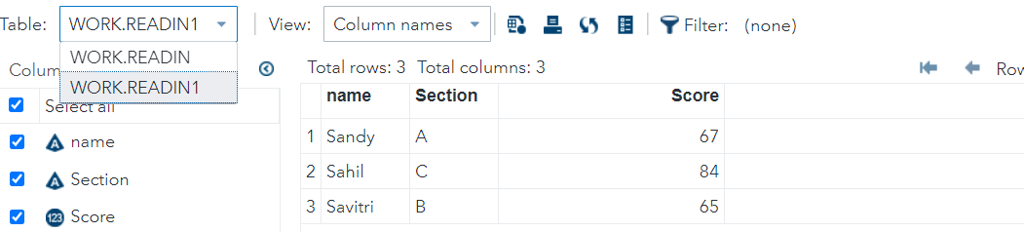

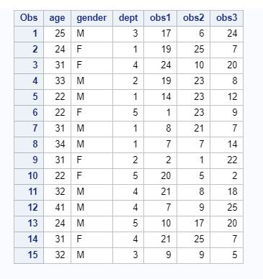 ?

How to import data into SAS? Upload files
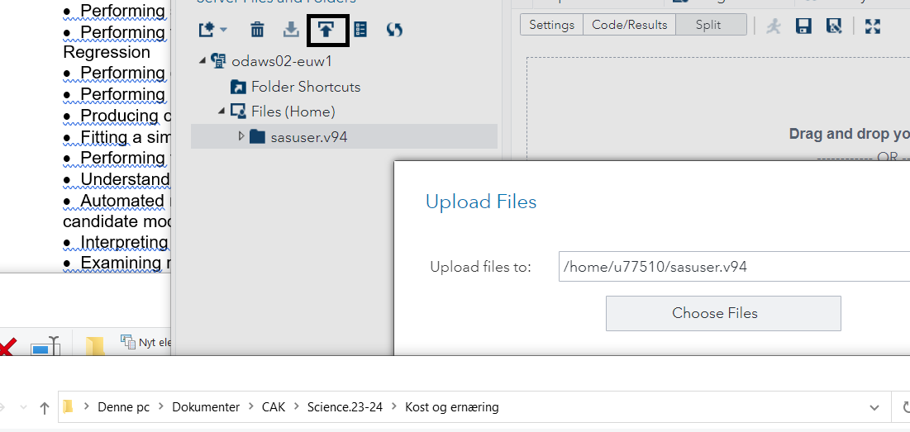

To perform the demonstrations and practices, you can write and submit code in SAS Studio, SAS Enterprise Guide, or the SAS Windowing environment, or you can use SAS Studio tasks. In addition to Base SAS software, you must have SAS/STAT.
In the course demos, we submit code in the SAS Studio programming environment, but you can view step-by-step task instructions by clicking the Task Version button below the video. The task-generated code and results might differ from those shown in the video, so the generated code is included for verification.
You can also write code or use SAS Studio tasks to complete the practices. Just select the Open Code Version or the Open Task Version button on the Practice page.
All task steps were written for SAS Studio 3.7. If you are using your own software, you can use the Downloads page to upgrade your SAS Studio Single-User Edition to the latest release, including hot fixes. If you don't have your own software, you can use SAS OnDemand for Academics to access SAS Studio free of charge.

Program Files
The course files are divided among 4 folders. The ECST142 folder contains SAS programs to setup the course environment and data, and three subfolders:
- data - the SAS data sets needed to run the demos and practices will be stored here.
- demos - contains the demo program files.
- solutions - contains the solution program files.
Demo and solution program names are in the form st1XXyZZ.sas where st1 is the course code, XX is a 2-digit lesson number, y is either d for demo or s for solution, and ZZ is a two-digit number to uniquely identify the file. For simplicity, the demo and solution files are each numbered sequentially within a lesson. For example, st102d03.sas is the third demo in lesson 2, and st104s02.sas is the solution to the second practice in lesson 4. The filename is included in a comment at the top of each program.

SAS Syntax
Partial SAS syntax is displayed and explained in the demos. To view detailed syntax from SAS Studio, click the Help button near the top right and select SAS Product Documentation. You can also navigate to support.sas.com/documentation.

Exploring SAS Data Sets in SAS Studio
You can use the table viewer in SAS Studio to explore SAS data sets.
- Open SAS Studio. In the navigation pane on the left, double-click Libraries. Expand My Libraries and then expand the SASHELP library.
- Open the CARS data set by double-clicking it or by dragging it to the work area on the right. The data set opens in the table viewer. By default all of the columns and the first 100 rows are displayed. You can use the arrows above the table (top right) to page forward and backward through the rows.

- Clear the Select all checkbox in the Columns area of the table viewer. No columns are displayed. Select the Make, Model, and Type checkboxes. The corresponding columns are displayed.

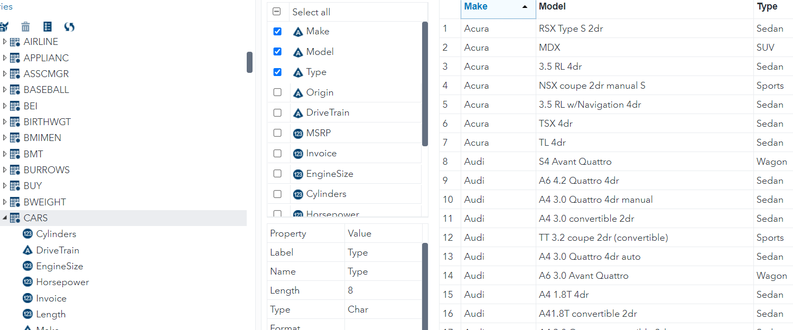
- Select Make in the column list. The column properties are displayed below the list.

- Close the table tab.
You can also use SAS Studio tasks to explore your data. The List Data task displays the rows of a SAS data set, and the List Table Attributes task displays its metadata including the number of columns and rows, and the name, type and length of each column.

Exploring SAS Data Sets Programmatically

You can use the PRINT procedure to display the rows of a SAS data set,

CONTENTS procedure display metadata for dataset
In the PROC PRINT step, you use the DATA= option to name the input data set and the VAR statement to select the columns to display. By default, SAS lists all columns and all rows, but you can use the OBS=n data set option to limit the display to the first n rows.
In the PROC CONTENTS step, you use the DATA= option to name the input data set.
Sample Code
proc print data=sashelp.cars(obs=100);
var Make Model Type MSRP;
run;
proc contents data=sashelp.cars;
run;

læser FROM SASHELP.CARS, laver tabel WORK.query med indholdet, vha sql-format
PROC SQL;
CREATE TABLE WORK.query AS
SELECT Make , Model , 'Type'n , Origin , DriveTrain , MSRP , Invoice , EngineSize , Cylinders , Horsepower , MPG_City , MPG_Highway , Weight , Wheelbase , 'Length'n FROM SASHELP.CARS;
RUN;
QUIT;

Dette datasæt behandles videre, input= WORK.query , der udskrives så detaljer til OUT
PROC DATASETS NOLIST NODETAILS;
CONTENTS DATA=WORK.query OUT=WORK.details;
RUN;
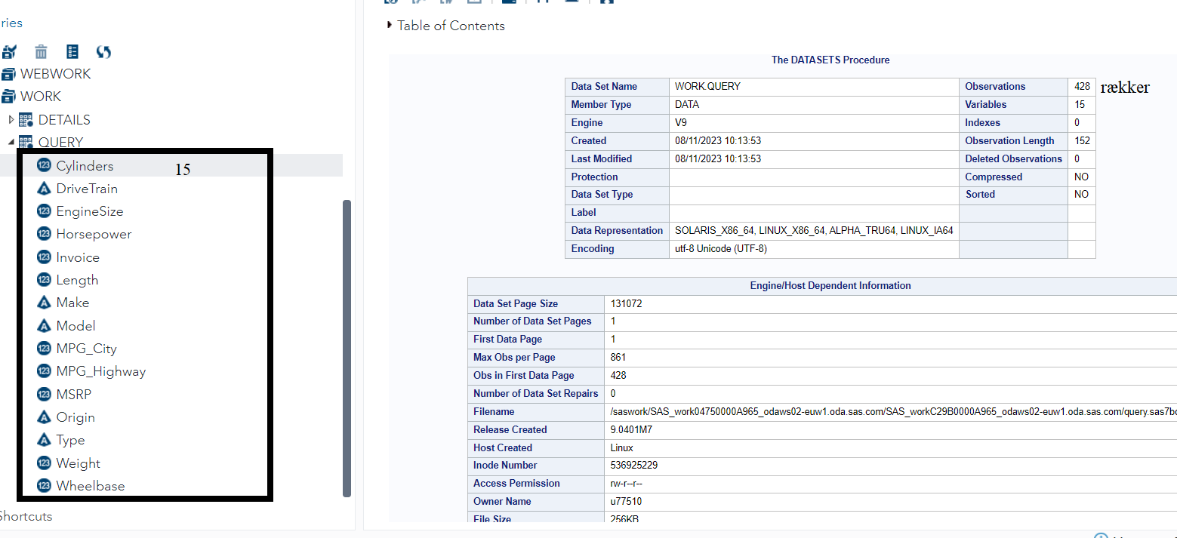

PROC PRINT DATA=WORK.details;
RUN;
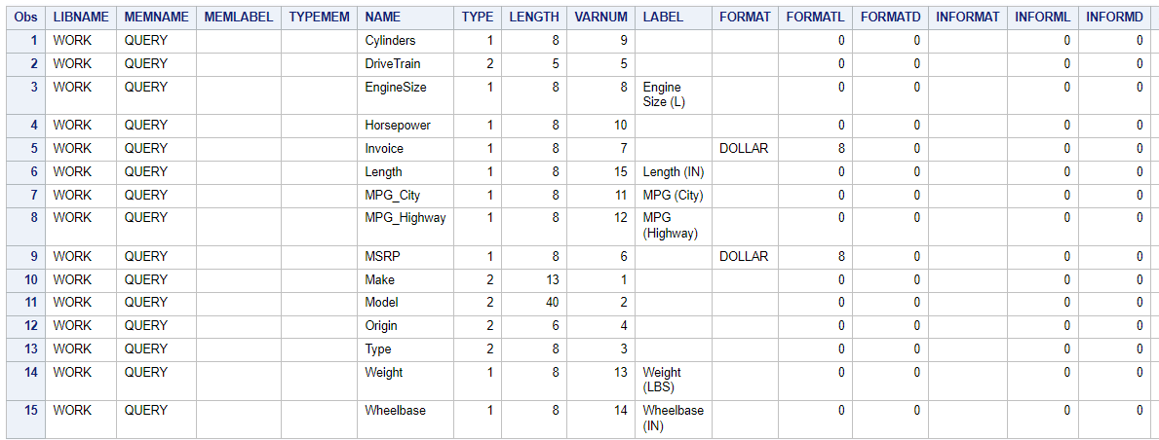

Level 2 Practice: Using Procedures to Validate Data, uni(1)-variate analyse
The pg1.np_summary table contains information about US national parks, monuments, preserves, rivers, and seashores. Valid values and descriptions for the columns Reg and Type are as follows:
Reg | Description | Type | Description
A | Alaska | NM | National Monument
IM | Intermountain | NP | National Park
MW | Midwest | NS | National Seashore
NC | National Capital | PRE | National Preserve
NE | Northeast | RVR | National River
PW | Pacific West
SE | Southeast
Reminder: If you restarted your SAS session,you must recreate the PG1 library so you can access your practice files. In SAS Studio, open and submit the libname.sas program in the EPG1V2 folder. In Enterprise Guide, run the Autoexec process flow.
Setup.sas
Createdata.sas opretter (virtuelt?, ser nemlig ikke fysisk mappe) PG1 mappe med række tabeller,
- Create a new program.
  - Write a PROC FREQ step to produce frequency tables for the Reg and Type columns in the pg1.np_summary table.
  - Submit the step and look for invalid values.

proc freq data=pg1.np_summary;
tables Reg Type;
run;

- What invalid values exist for Reg?
No invalid values exist for Reg.
- What invalid values exist for Type?
NPRE, PRESERVE, and RIVERWAYS are invalid values for Type.
- Write a PROC UNIVARIATE step to generate statistics for the Acres column in the pg1.np_summary table. Submit the step.
proc univariate data=pg1.np_summary;
var Acres;
run;

- What are the observation numbers for the smallest park and the largest park?
Smallest: Observation 78
Largest: Observation 6
- View the pg1.np_summary table to identify the name and size of the smallest and largest parks.
Smallest: African Burial Ground Monument, .35 acres
Largest: Noatak National Preserve, 6,587,071.39 acres

options linesize=256;

data CLASS_BIRTHDATE;
attrib Name length=$8;
attrib Sex length=$1;
attrib Age length=8;
attrib Height length=8;
attrib Weight length=8;
attrib Birthdate length=8;

infile datalines dsd;
input
Name
Sex
Age
Height
Weight
Birthdate
;
datalines4;
Alfred,M,14,69,112.5,16370
Alice,F,13,56.5,84,16756
Barbara,F,13,65.3,98,16451
Carol,F,14,62.8,102.5,16256
Henry,M,14,63.5,102.5,16406
James,M,12,57.3,83,16967
Jane,F,12,59.8,84.5,16873
Janet,F,15,62.5,112.5,15797
Jeffrey,M,13,62.5,84,16552
John,M,12,59,99.5,17036
Joyce,F,11,51.3,50.5,17169
Judy,F,14,64.3,90,16410
Louise,F,12,56.3,77,17021
Mary,F,15,66.5,112,15790
Philip,M,16,72,150,15665
Robert,M,12,64.8,128,16958
Ronald,M,15,67,133,15992
Thomas,M,11,57.5,85,17243
William,M,15,66.5,112,16067
;;;;
run;

Challenge Practice: Generating Extreme Observations Output
The pg1.eu_occ table includes monthly occupancy counts for European countries between January 2004 and September 2017.

The SAS Output Delivery System (ODS)

gives you options for controlling the type and format of the output that is generated by SAS code. The ODS SELECT statement is used to specify output objects for results. The ODS SELECT statement can be used to generate a report containing only the Extreme Observations output.
Note: To specify an output object, you need to know which output objects your SAS program produces. The ODS TRACE statement writes to the SAS log a trace record that includes the path, the label, and other information about each output object that your SAS program produces. You can find documentation about the ODS TRACE and ODS SELECT statements in the SAS Help Facility and in the online documentation.
Reminder: If you restarted your SAS session, you must recreate the PG1 library so you can access your practice files. In SAS Studio, open and submit the libname.sas program in the EPG1V2 folder. In Enterprise Guide, run the Autoexec process flow.
data vist 9 /data mappen
- Create a new program. Write a PROC UNIVARIATE step to examine Camp-værdier in the pg1.eu_occ table.

Univariate analyse finder median, quantiler , spredning for een dataserie,min,max

Trace giver info om hvert output, er i sig selv et objekt i systemet

Solution:
proc univariate data=pg1.eu_occ;
var camp;
run;

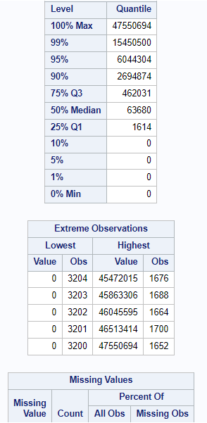

- Add the ODS TRACE ON statement before the PROC UNIVARIATE step, and add the ODS TRACE OFF statement after the PROC UNIVARIATE step. Submit the program.

Solution:
ods trace on;
proc univariate data=pg1.eu_occ;
var camp;
run;
ods trace off;

- Examine the trace information in the SAS log. What is the name of the Extreme Observations output object?

Solution:
Output Added:
-------------
Name: ExtremeObs
Label: Extreme Observations
Template: base.univariate.ExtObs
Path: Univariate.Camp.ExtremeObs

ExtremeObs
Delete the ODS TRACE statements. Add an ODS SELECT statement immediately before the PROC UNIVARIATE step and provide the name of the Extreme Observation output object. Submit the program.
se nedenfor
Note: This method can be used with other procedures that create multiple tables (such as PROC CONTENTS) to select a portion of the output.

ods select extremeobs; udvælger specifikt delement

Solution:
ods select extremeobs;
proc univariate data=pg1.eu_occ;
var camp;
run;

- How many extreme observations are listed?

Solution:
The five lowest and highest extreme observations are listed.
- Using the SAS documentation or the syntax Help in the editor, identify the option that specifies the number of extreme observations that are listed in the table. Use the option to change the number of extreme observations from five to 10. Submit the program.

Solution:
ods select extremeobs;
proc univariate data=pg1.eu_occ nextrobs=10;
var camp;
run;

**** kursus-link, stadigt aktiv, større kursus

https://vle.sas.com/course/view.php?id=11088&section=0

https://welcome.oda.sas.com/ sign in page

Course Overview & Objectives
This course is for users who want to learn how to write SAS programs to access, explore, prepare, and analyze data. In this course, you will learn how to write SAS code to handle the most common data processing tasks. We'll use the following steps for teaching you the fundamentals of the SAS programming language:
- Essentials of SAS Programming
Use SAS Studio and SAS Enterprise Guide to write and submit SAS programs.
- Accessing data or reading it with a program
Access SAS, Microsoft Excel, and text data.
- Exploring the data to see what's there and what you might need to add or change
Explore and validate data.
- Preparing the data for analysis
Prepare data by subsetting rows and computing new columns.
- Analyzing and reporting on the data
Analyze and report on data.
- Export results to various report and data formats
Export data and results to Excel, PDF, and other formats.
- Using SQL

Opsætning

Create the practice files for the course — you only have to do this once.
- In the Files and Folders panel, navigate to the EPG1V2 folder.
- Double-click createdata.sas to open it.
- Click Run or press F3 to submit the program to SAS. This program creates SAS data sets in the data folder.
- Check the log to verify that there are no errors or warnings. There will be many notes because SAS writes a note for each data set that the program creates.
Note: If your program does not run successfully, make sure you completed all the steps in Task 2 correctly.
- Close the createdata.sas program tab in the workspace.

- At the top of the Files and Folders panel, click New and select SAS Program to open a new program tab. You are ready to work in SAS Studio.
Note: Unless you delete your practice files, you do not need to perform this task again.
%include "&path/pg1v2.sas";
proc contents data=pg1._all_ nods;
run;

!! Fejl med option locale=da_GL

/home/u77510/sasuser.v94/EPG1V2/createdata.sas kan afvikles uden fejl
, denne sprogfejl, her:
/***********************************************/
/* In the line of code below, replace FILEPATH */
/* with the path to your EPG1V2/data folder */
/***********************************************/

%let path=/home/u77510/sasuser.v94/EPG1V2/data;

/**********************************************/
/* DO NOT EDIT THE CODE BELOW */
/**********************************************/

libname PG1 "&path";

/**********************************************/
/* You must run SETUP.SAS before you run */
/* this code to create your data for EPG1V2 */
/* */
/* DO NOT EDIT THE CODE BELOW */
/**********************************************/

%include "&path/pg1v2.sas";

proc contents data=pg1._all_ nods;
run;

pg1v2.sas file laver en række datasæt:
/*++++++++++++++++++++++++++++++++++++++++++++++++++++++++++++
WARNING: STUDENTS, DO NOT EXECUTE THIS PROGRAM! INSTEAD,
EXIT AND EXECUTE THE CRE8DATA.SAS PROGRAM TO SETUP
YOUR COURSE DATA ENVIRONMENT.
+++++++++++++++++++++++++++++++++++++++++++++++++++++++++++*/

/*++++++++++++++++++++++++++++++++++++++++++++++++++++++++++++
WARNING: DO NOT ALTER CODE BELOW THIS LINE
+++++++++++++++++++++++++++++++++++++++++++++++++++++++++++*/

options linesize=256;

data ./PG1.CLASS_BIRTHDATE;
attrib Name length=$8;
attrib Sex length=$1;
attrib Age length=8;
attrib Height length=8;
attrib Weight length=8;
attrib Birthdate length=8;

infile datalines dsd;
input
Name
Sex
Age
Height
Weight
Birthdate
;
datalines4;
Alfred,M,14,69,112.5,16370
Alice,F,13,56.5,84,16756
Barbara,F,13,65.3,98,16451
Carol,F,14,62.8,102.5,16256
Henry,M,14,63.5,102.5,16406
James,M,12,57.3,83,16967
Jane,F,12,59.8,84.5,16873
Janet,F,15,62.5,112.5,15797
Jeffrey,M,13,62.5,84,16552
John,M,12,59,99.5,17036
Joyce,F,11,51.3,50.5,17169
Judy,F,14,64.3,90,16410
Louise,F,12,56.3,77,17021
Mary,F,15,66.5,112,15790
Philip,M,16,72,150,15665
Robert,M,12,64.8,128,16958
Ronald,M,15,67,133,15992
Thomas,M,11,57.5,85,17243
William,M,15,66.5,112,16067
;;;;
run;

ellers får jeg denne fejl:
ERROR 14-12: Invalid option value DA_GL for SAS option LOCALE.
https://odamid-euw1.oda.sas.com/SASStudio/main?locale=da_GL&zone=GMT-01%253A00&https%3A%2F%2Fodamid-euw1.oda.sas.com%2FSASStudio%2Findex=
når jeg logger ind sættes locale=da_GL automatisk, det giver fejl
https://odamid-euw1.oda.sas.com/SASStudio/main?locale=da_DK&zone=GMT-01%253A00&ticket=ST-45057-w7wqxXXetoIz2EkwhOf7-cas

option locale=da_da language=da
OPTIONS LOCALE=da_DK DFLANG=LOCALE;
Autoexcec forsøgt rettet , stadig fejl
1 OPTIONS NONOTES NOSTIMER NOSOURCE NOSYNTAXCHECK;
4 OPTIONS LOCALE=da_GL DFLANG=LOCALE;
______
14
ERROR 14-12: Invalid option value DA_GL for SAS option LOCALE.

72
73 OPTIONS LOCALE=da_DK DFLANG=LOCALE;

How Locale Is Specified during a SAS Session
You can use the LOCALE= system option to specify the locale of the SAS session during the SAS session. However, only the values for these system options change implicitly to reflect the changed value of LOCALE=:
- DFLANG=
- PAPERSIZE=
Note: The PAPERSIZE option is affected only if it is set to LOCALE. For more information see PAGESIZE= System Option in SAS System Options: Reference.
The value for the ENCODING= system option does not change implicitly to reflect the changed value of LOCALE=.
The Italian_Italy value that is assigned to the LOCALE= option implicitly resets the following options during the SAS session to reflect the changed value of the LOCALE= system option:
- DFLANG=Italian
- PAPERSIZE=A4
Language Switching
SAS messages are displayed in the language that is specified by the settings in the SAS configuration file during start up. You can view SAS messages in another language by using the language switching feature. You can access the language switching feature with the ODSLANGCHG system option. If ODSLANGCHG is enabled, then the value of the LOCALE system option determines the language for procedure output, user interface elements, and ODS fonts. If ODSLANGCHG is disabled, then messages appear in the language that is set during start up. This feature is supported on any server as long as the characters of the messages are supported by the encoding. For more information, see the ODSLANGCHG System Option. The LSWLANG system option specifies the language for the language switching feature when the LOGLANGCHG or ODSLANGCHG system option is set at SAS invocation. The LSWLANG system option has higher priority over the LOCALE system option. If the LSWLANG option is set to a valid SAS language, the SAS log output is controlled by its value. Otherwise, the LOCALE= option determines the language of the SAS log.
The LOGLANGCHG system option controls whether language switching occurs for the SAS log messages. This option controls the language of message switching in SAS log output. If LOGLANGCHG is specified, the language of the SAS log depends on the LSWLANG or LOCALE= option. For more information, see LOGLANGCHG System Option.
The LSWLANG option specifies the language of messages if LOGLANGCHG or ODSLANGCHG are enabled. If LSWLANG is set to LOCALE, the LOCALE= option determines the language for switching. LSWLANG=LOCALE is the default. For more information, see LSWLANG System Option.
The LOGLANGENG option is a toggle option that overrides LOGLANGCHG and LSWLANG and sets them to LOGLANGCHG=ON and LSWLANG=EN. As a result, the LOG output is in English, and the NL format output does not change. This option changes the setting of ODSLANGCHG. If ODSLANGCHG=OFF, the system message language for ODS output is determined by SAS configuration. If ODSLANGCHG=ON, all messages are in English because of the LSWLANG setting. For more information, see LOGLANGENG System Option.
For more information about Language Switching, see Multilingual Computing with SAS® 9.4.

74
75 OPTIONS NONOTES NOSTIMER NOSOURCE NOSYNTAXCHECK;
87

