Gode links
https://www.w3schools.com/r/r_variables.asp få skærm bred, så oversigts fanen ses

https://bookdown.org/ndphillips/YaRrr/test-your-r-might-mmmmmcaffeine.html

få vist overskrifterne i Navigatoinsruden: /vis/Navigationsrude[x]

platformen
- Guide
- User Interface
- Pane Layout
Pane Layout
The RStudio user interface has 4 primary panes:
- Source pane
- Console pane
- Environment pane, containing the Environment, History, Connections, Build, VCS , and Tutorial tabs
- Output pane, containing the Files, Plots, Packages, Help, Viewer, and Presentation tabs
Each pane can be minimized or maximized within the column by clicking the minimize/maximize buttons .
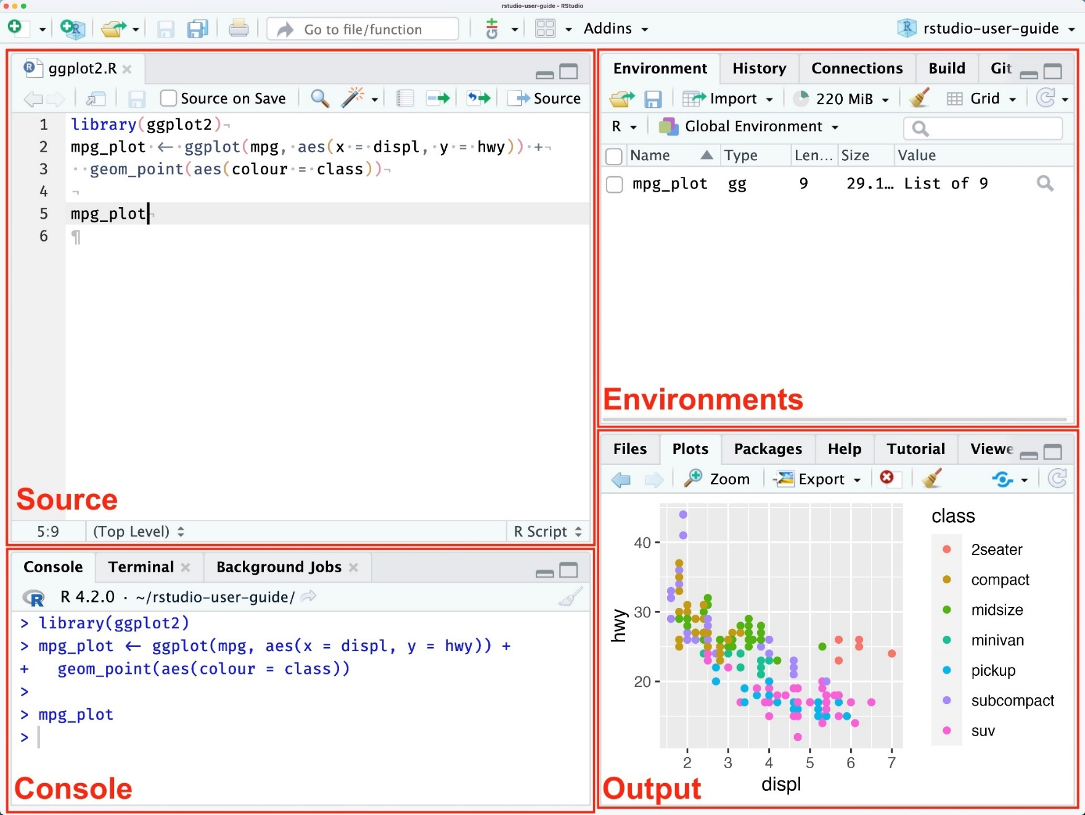
The documentation below provides information based on the default layout/options of each pane. The specific components within each pane and overall arrangement of panes can be modified by opening the Tools > Global Options > pane Layout.
Additional source “columns” can be added to the left of the four primary panes. To add additional source columns, from the RStudio menu: Global Options > Pane Layout > Add Source Column, which provides the ability to work on two (or more) source files at a time within the Source Pane.
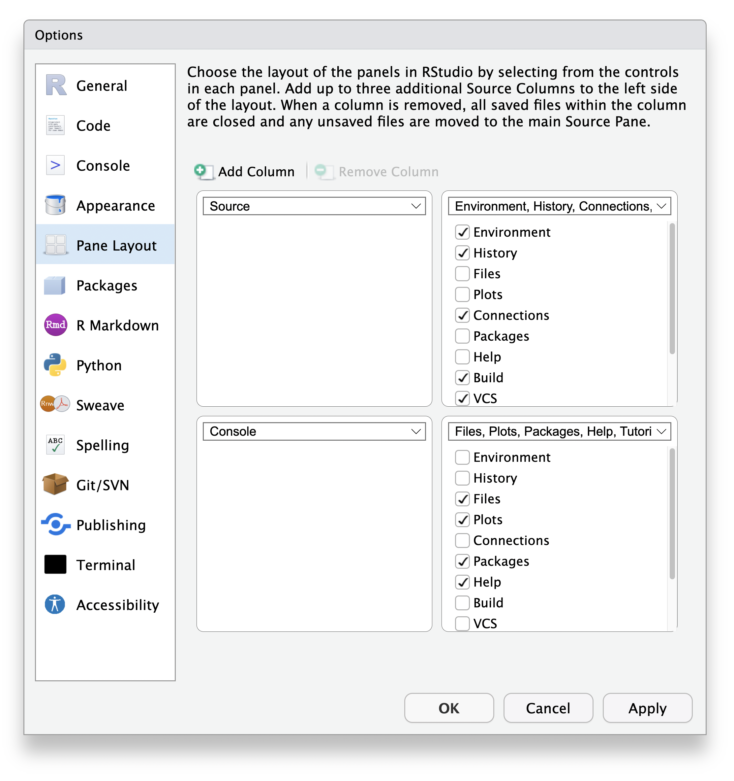
Source
The source pane allows users to view and edit various code-related files, such as .R, .rmd, .qmd, .py, .css, or general text files such as .txt or .md. By default it is the top-left panel and can be launched by opening any editable file in RStudio. Each additional file that is opened will be added as a new tab within the Source pane.
Additional source “columns” can be added to the left of the four primary panes. To add additional source columns, from the RStudio menu: Global Options > pane Layout > Add Source Column, which provides the ability to work on two (or more) source files at a time within the Source pane.
Individual source files can also be opened in their own window, rather than only within the Source pane. Source windows allow you to edit files outside the main RStudio window. This is useful for splitting your work among multiple monitors, or devoting more space to your editor.
Creating Source Windows
There are two ways to open a new source window:
Pop out an editor: click the Show in New Window button in any source editor tab.
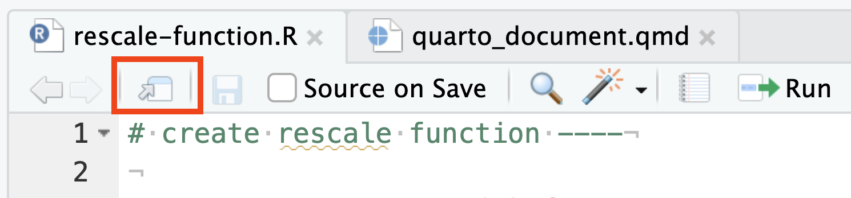
Tear off a pane: drag a tab out of the main Source pane and onto the desktop; a new source window will be created where you dropped the tab.
You can have as many source windows open as you like.
Managing Source Windows
Each source window has its own set of tabs; these tabs are independent of the tabs in RStudio’s main source pane.
To return a document to the main window, click the Return to Main Window button on the editor toolbar.
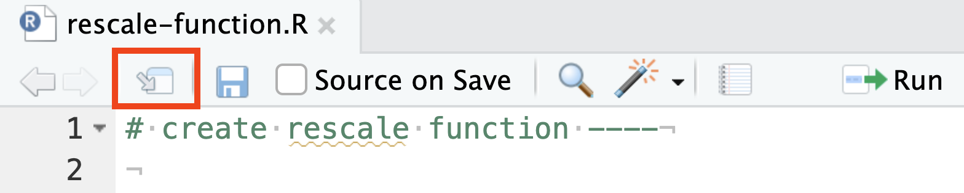
Navigating to Source Windows
The easiest way to jump to a source window is to use the global Go To File/Function tool (Ctrl + .). Begin typing the name of the file you want to navigate to; when it appears, select it and press Enter.
When a document is open in a source window, RStudio will jump to that window whenever you navigate to the document, or to a symbol in the document.
You can also use the shortcut Ctrl+1 to go to the last source window that had focus (which may be the main RStudio source pane).
Based on the type of file, specific menu-bar options will be available. A subset of important file types are discussed below.
.R
R source files .R have a Undo/Redo arrows, a Show in New Window button to tear out that pane into it’s own window, a Save button along with a “Source on Save” button that will source the entire script each time it is saved. There is Find/Replace button and then code-tools button. A .R file can be compiled into a report.
The right side of the menu bar has a run button to run the selected line, a Re-Run button to rerun the previous code, a source drop-down button for sourcing the file silently, with echo, or as a Background Job. The last icon opens a document outline which will display section labels in the code. Section labels are written as special comments:

Oversigt over afsnit I R-filer, med # tekst ----
# section name ----
Subsections can be indicated by increasing the number of #:

# Heading 1 =navn på section ----
## Subheading ----
### Smaller subheading ----

# Section 2 ----
## Subheading 2 ----
.qmd
Quarto documents (.qmd) have a toggle-able Source or Visual mode for displaying real time view of the formatted markdown, along with a Save button, a Render on Save, Spellcheck, search, Render button, a gear for selecting whether to have inline output or output to the R console or Plot pane.
On the right side of the menu bar there is a section for adding specific language code chunks, a dropdown for running various methods of the code, and a blue publish button for publishing to Posit Connect, Shinyapps.io, Quarto Pubs or RPubs.

Console
By default the console pane is the bottom left pane. The console pane provides an area to interactively execute code. By default it is tied to R, but through the use of the reticulate package, it can also provide a Python console.
The Console pane also includes an integrated Terminal tab for executing system commands, adding or removing additional integrated terminals, as well as general controls of the current selected terminal.
The Background Jobs tab provides the ability to send long running R scripts to local and remote background jobs. This functionality can dramatically improve the productivity of data scientists and analysts using R since they can continue working in RStudio while jobs are running in the background.
Ctrl+1 — Move focus to the Source pane Ctrl+2 — Move focus to the Console Ctrl+L — Clear the Console Esc — Interrupt R
Environment pane
By default, the Environment pane is located in the top-right and includes the Environment, History, Connections, Build, and Version Control System (VCS) tabs.
Environment
The environment tab displays currently saved R and Python objects. For example, the following code would add avg_mpg to the environments pane for the duration of the current session.
avg_mpg <- mean(mtcars$mpg)
The R icon can be toggled between R or Python environment objects.
The environment menu bar provides loading or saving of R Workspaces, interactive import of datasets from text files, Excel, or SPSS/SAS/Stata. It also displays the memory currently used by the active R session, and a broom icon to remove all of the current environment objects.
History
The history tab displays the commands that were executed in the current session along with search. There are buttons for loading/saving the command history to a file, as well as sending the selected command into the console or inserting it into the current working document. There is a delete button for deleting the selected history or the broom button for removing all history of the current session.
Connections
The connections tab displays connections to local or remote databases or pins. Additional possible connections can be added by installing database drivers or specific R packages. You can interactively click on available connections and it will provide generic R code to register an active connection with that data source. Once the connection is created, you can then explore available tables or pins in that connection.
There is also a Connect button for creating a connection in the R console, script, or a notebook, as well as copying the relevant code to the clipboard if available.
Build
The Build tab is available in specific R projects that interact with it such as R packages or Quarto/R Markdown websites/books
Based on the type of R Project, the build pane will provide options for building the R Package or rendering the website.

VCS (Version Control System)
The VCS tab will change based on the version control system you have enabled for that session. For example, using Git will change the tab name to Git and provide commands for:
- Viewing diffs
- Committing selected files
- Performing Pull or Push commands
- Viewing the version control history
- Adding selected files to the .gitignore
- Creating or selecting a specific branch
Output pane
By default, the Output pane is the bottom-right pane and displays various outputs such as plots, HTML content, or on-disk files. It contains the Files, Plots, R Packages, Help, Tutorial, Viewer, and Presentation tabs.
Files
This tab provides interactive exploration of the current R Project along with the entire directory. There are menu bar options for adding new folders, new blank files, deletion/renaming of files, as well as a gear pane for additional functions.
Plots pane
This tab will display static images generated by code until the session is restarted. There are backwards and forwards arrows for navigating between older and newer plots that have been displayed, a Zoom feature, an export button for saving displayed outputs, a delete button for removing the currently displayed image, and a broom icon which will clear ALL temporary plots from this tab
Packages
The package tab allows for viewing currently installed R packages, and has a search bar for searching the current library of packages. There is an install and update button for installation of new packages or updating existing selected packages.

Help
The help tab is used to display package documentation and vignettes. There are arrows for navigating backwards and forwards as additional help pages are viewed. The home icon will return to the general help page, with links to Resources, Manuals, References, and Posit Support.
To get help on a specific R function use the ?functionName or help(functionName) syntax, for example the following code when executed would open the help page for the paste0() function:
?paste0()
# or
help(paste0)
Additionally, sections of code can be highlighted and executed in the R console with the Ctrl+Enter shortcut (Cmd+Enter on Mac).
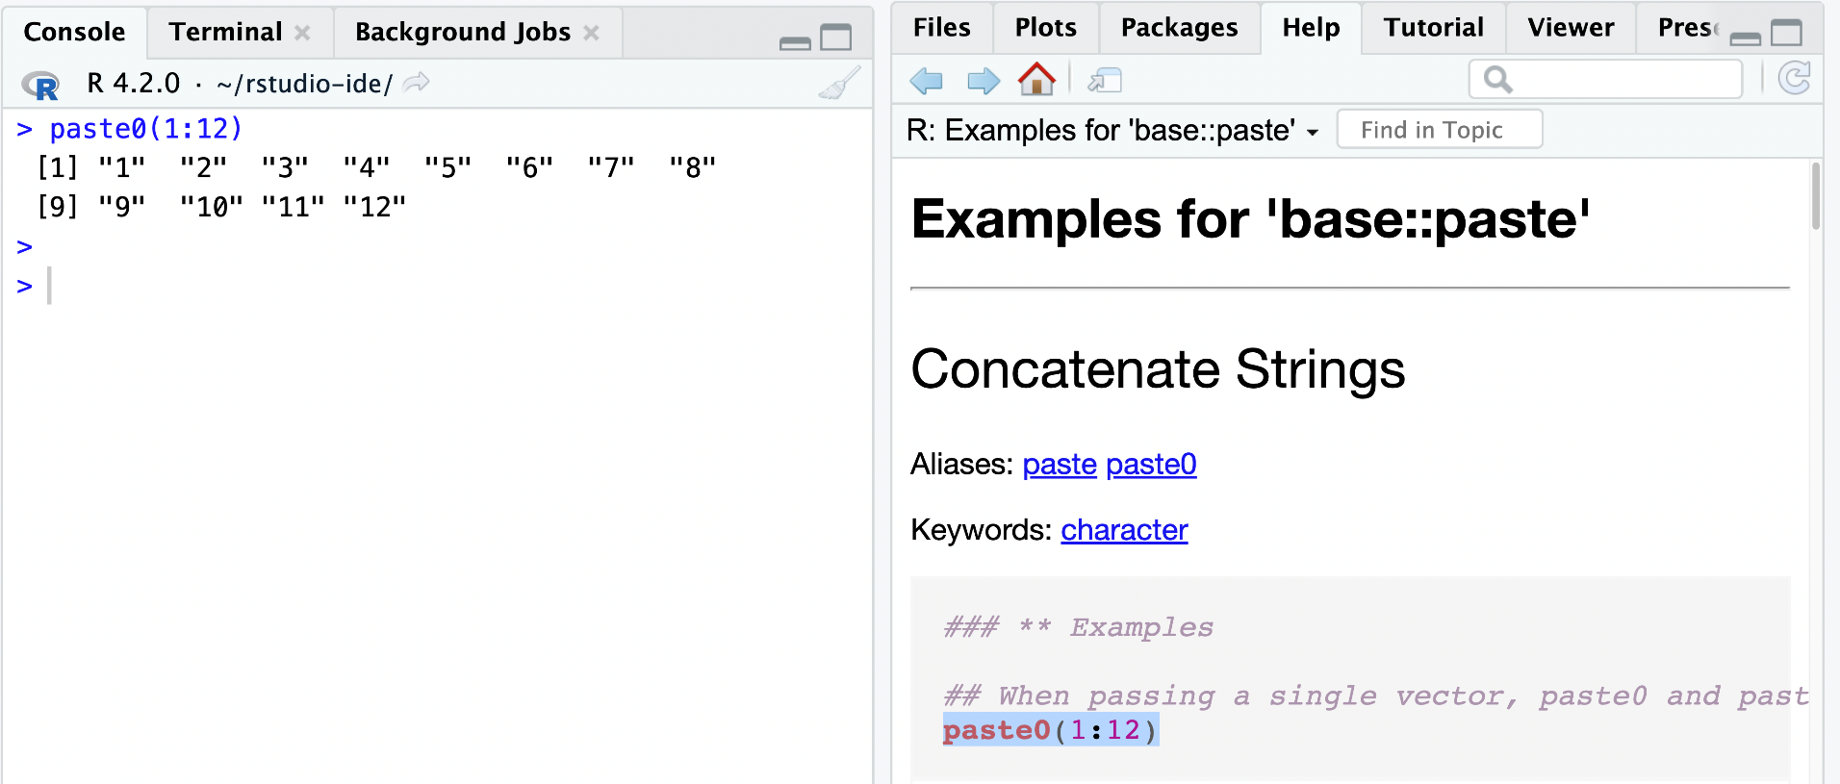
Tutorial
The tutorial tab is used to load interactive learnr tutorials. These tutorials provide an interactive environment to step through lessons that package authors or educators have written.
Viewer
The viewer tab is used to display web content such as Shiny apps, Quarto generated web pages, or interactive htmlwidgets like plotly graphs.
Presentation
The Presentation tab is used to display HTML slides generated via Quarto’s revealjs format.

/File/Import Dataset kan bruge til indlæsning af mange typer dataset til dataframes

installed version: 2024.04.2 Build 764

Working directory, hvor filer gemmes default, kan ændres:
getwd()
[1] "C:/Users/bh/Documents"
.Rhistory R History Source File (.Rhistory) gemmer vist alle indtastninger i fil, der kan åbnes i Notepad, normalt skjult pga .

It is setwd("path/to/new/dir")
setwd("C:/Users/bh/Documents/programmering/R")
- Either via a Windows property, or via .Rprofile etc, or (as I recall) by defining $HOME which Windows does not set by default. See help(Startup).

print("Hello World!")
And there are times you must use the print() function to output code, for example when working with for loops (which you will learn more about in a later chapter):

Example
for (x in 1:10) {
print(x)
}

"Hello World!" # This is a comment
markér begge disse linjer:
name <- "John"
age <- 40
copy/paste -> tryk return
name # output "John"
age # output 40

#kommentarer
# This is a comment
# written in
# more than just one line
"Hello World!"

Concatenate Elements
text <- "awesome"
paste("R is", text)

# Assign the same value to multiple variables in one line
var1 <- var2 <- var3 <- "Orange"

# Print variable values
var1
var2
var3

alle lig "Orange"

Variable Names
A variable can have a short name (like x and y) or a more descriptive name (age, carname, total_volume). Rules for R variables are:
A variable name must start with a letter and can be a combination of letters, digits, period(.)
and underscore(_). If it starts with period(.), it cannot be followed by a digit.
A variable name cannot start with a number or underscore (_)
Variable names are case-sensitive (age, Age and AGE are three different variables)
Reserved words cannot be used as variables (TRUE, FALSE, NULL, if...)

Multiline comments:
On Windows, highlight the text and use CTRL+SHIFT+C to comment multiple lines, sætter # for hver linje
"This function takes a value x, and does things and returns things that
take several lines to explain"

# Illegal variable names:
2myvar <- "John"
my-var <- "John"
my var <- "John"
_my_var <- "John"
my_v@ar <- "John"
TRUE <- "John"

Basic Data Types
Basic data types in R can be divided into the following types:

numeric - (10.5, 55, 787)
integer - (1L, 55L, 100L, where the letter "L" declares this as an integer)
complex - (9 + 3i, where "i" is the imaginary part)
character (a.k.a. string) - ("k", "R is exciting", "FALSE", "11.5")
logical (a.k.a. boolean) - (TRUE or FALSE)

We can use the class() function to check the data type of a variable:

# ls() function list the objects in the current working environment
ls()

File-typer
.rdata R-workspace fil, kan ikke ses i RStudio, file/open -> load("~/programmering/R/data/ibm.rdata")
.rda R-datafile?, kan ikke ses i RStudio, file/open -> load(filename)
The .rda files allow a user to save their R data structures such as vectors, matrices, and data frames. The file is automatically compressed, with user options for additional compression.
save 3 datasets to rda fil: save(count, age, circumference, file = "mydata.rda")
rda is just a short name for RData. You can just save(), load(), attach(), etc. just like you do with RData.
.R er filer med R-kode, kan ses i RStudio og i normal edtior
When I want to see what's in an.rda file without loading it into my current environment, I load it into a temp env:
e <- new.env(parent = emptyenv())
load("path/to/file.rda", envir=e)
ls(e) # shows names of variables stored in it
ls.str(e) # shows a `str` presentation of all variables within it

ceiling() and floor()
The ceiling() function rounds a number upwards to its nearest integer, and the floor() function rounds a number downwards to its nearest integer, and returns the result:

Strings
"hello" is the same as 'hello'

Multiline Strings
str <- "Lorem ipsum dolor sit amet,
consectetur adipiscing elit,
sed do eiusmod tempor incididunt
ut labore et dolore magna aliqua."
cat(str)

cat(str) udskriver med escape-char aktive; med print(str), str vises fx linjeskift kun som indlejret \n
However, note that R will add a "\n" at the end of each line break. This is called an escape character, and the n character indicates a new line.
If you want the line breaks to be inserted at the same position as in the code, use the str <- "Lorem ipsum dolor sit amet,
consectetur adipiscing elit,
sed do eiusmod tempor incididunt
ut labore et dolore magna aliqua."
cat() function:
cat(str)

String Length
There are many usesful string functions in R.
For example, to find the number of characters in a string, use the nchar() function:
Example
str <- "Hello World!"
nchar(str)

R String Manipulation Functions - I bet you will master its Usage! - DataFlair (data-flair.training)

Check a substring in a String
Use the grepl() function to check if a character or a sequence of characters are present in a string, return TRUE/FALSE
str <- "Hello World!"

grep() bruge regExpr søgning
grepl("H", str) # ‘H’ in str
grepl("Hello", str) #Hello I str, ja
grepl("X", str)
grep("b+", c("abc", "bda", "cca a", "abd"), value=TRUE) # value=FALSE giver kun nr b forekommer og 0+ chars
#[1] "abc" "bda" "abd"
grep("b+", c("abc", "bda", "cca a", "abd"), value=FALSE) # value=FALSE giver kun nr i c
#[1] 1 2 4

sprintf() : This function makes of the formatting commands that are styled after C.
sprintf("%s scored %.2f percent", "Matthew", 72.3)

str = "Splitting sentence into words"
strsplit(str, " ")

Trim string: fjerne whitespace char
syntax:
library(stringr)
str_trim(string, side = c(“both”, “left”, “right”))

regexpr() it represents a character vector where matches are sought.
Introduction.R filen
grep("b+", c("abc", "bda", "cca a", "abd"), perl=TRUE, value=FALSE) #regExpr søgning, mindst en b
# søger efter netop 1 b : [1] 1 2 4 findes ikke i nr 3
grep("b+", c("abc", "bbda", "cca a", "abd"), value=TRUE)
#[1] "abc" "bbda" "abd"
grep("[0-9]+", c("a12", "2bda","1","34","cca a", "abd"), value=TRUE) #mindst 1 d
grep("[0-9]{2}", c("a12", "2bda","1","34","cca a", "abd"), value=TRUE) #netop 2d
#[1] "a12" "34"
grep("\\d", c("a12", "2bda","1","34","cca a", "abd"), value=TRUE) #som [0-9]
grep("[0-9]+", c("a12", "2bda","1","34","cca a", "abd"), value=TRUE) #mindst 1 d
#[1] "a12" "2bda" "1" "34"
grep("[0-9]{2}", c("a12", "2bda","1","34","cca a", "abd"), value=TRUE) #netop 2d
#[1] "a12" "34"
grep("^[0-9]{2}$", c("a12", "2bda","1","34","cca a", "abd"), value=TRUE) #skal starte og slutte med 2d
# [1] 34"
# ^, $: start-of-line and end-of-line respectively. E.g., ^[0-9]$ matches a numeric string.
- Escape Sequences (\char):
- OR Operator (|): E.g., the regex four|4 accepts strings "four" or "4".
- Character class (or Bracket List):
  - [...]: Accept ANY ONE of the character within the square bracket, e.g., [aeiou] matches "a", "e", "i", "o" or "u".
  - [.-.] (Range Expression): Accept ANY ONE of the character in the range, e.g., [0-9] matches any digit; [A-Za-z] matches any uppercase or lowercase letters.
  - [^...]: NOT ONE of the character, e.g., [^0-9] matches any non-digit.
  - Only these four characters require escape sequence inside the bracket list: ^, -, ], \.
- Occurrence Indicators (or Repetition Operators):
  - +: one or more (1+), e.g., [0-9]+ matches one or more digits such as '123', '000'.
  - *: zero or more (0+), e.g., [0-9]* matches zero or more digits. It accepts all those in [0-9]+ plus the empty string.
  - ?: zero or one (optional), e.g., [+-]? matches an optional "+", "-", or an empty string.
  - {m,n}: m to n (both inclusive)
  - {m}: exactly m times
  - {m,}: m or more (m+)
- Meta-characters: matches a character
  - . (dot): ANY ONE character except newline. Same as [^\n]
  - \d, \D: ANY ONE digit/non-digit character. Digits are [0-9]
  - \w, \W: ANY ONE word/non-word character. For ASCII, word characters are [a-zA-Z0-9_]
  - \s, \S: ANY ONE space/non-space character. For ASCII, whitespace characters are [ \n\r\t\f]
- Position Anchors: does not match character, but position such as start-of-line, end-of-line, start-of-word and end-of-word.
  - ^, $: start-of-line and end-of-line respectively. E.g., ^[0-9]$ matches a numeric string.
  - \b: boundary of word, i.e., start-of-word or end-of-word. E.g., \bcat\b matches the word "cat" in the input string.
  - \B: Inverse of \b, i.e., non-start-of-word or non-end-of-word.
  - \<, \>: start-of-word and end-of-word respectively, similar to \b. E.g., \<cat\> matches the word "cat" in the input string.
\A, \Z: start-of-input and end-of-input respectively
grep("^[0-9]{2}$", c("a12", "2bda","1","34","cca a", "abd"), value=TRUE) #skal starte og slutte med 2d
# 34"
# ^, $: start-of-line and end-of-line respectively. E.g., ^[0-9]$ matches a numeric string.

Use the paste(str1,str2, sep = " ") function to merge/concatenate two strings:
Example
str1 <- "Hello"
str2 <- "World"
paste(str1, str2)
Example

The escape character allows you to use double quotes when you normally would not be allowed:
str <- "We are the so-called \"Vikings\", from the north."
Other escape characters in R:
Code Result
\\ Backslash
\n New Line
\r Carriage Return
\t Tab
\b Backspace
The nature of R means that you're never going to have a newline in a character vector when you simply print it out.

difference between cat and print
print("hello\nworld\n")
[1] "hello\nworld\n"
That is, the newlines are in the string, they just don't get printed as new lines. However, you can use other functions if you want to print them, such as cat:
cat("hello\nworld\n")
hello
world

Regular Expressions in R
A set of strings will define as regular expressions. We use two types of regular expressions in R, extended regular expressions (the default) and Perl-like regular expressions used by perl = TRUE.
https://regex101.com/ tester
Regular Expression Syntax
It specifies the characters to seek out, with information about repeats and location within the string. You can practice it with the help of metacharacters that have a specific meaning: $, *, +, ?, [ ], ^ , { }, |, ( ), \, .
/w3schools/i is a regular expression.
w3schools is a pattern (to be used in a search).
i is a modifier (modifies the search to be case-insensitive).

a <- 200
b <- 33
if (b > a) {
print ("b is greater than a")
} else {
print("b is not greater than a")
}
R Arithmetic Operators

^ | Exponent | x ^ y | Try it »
%% | Modulus (Remainder from division) | x %% y | Try it »
%/% | Integer Division | x%/%y

R Assignment Operators

my_var <- 3
my_var <<- 3 global variabel
4 -> my_var
3 ->> my_var
my_var # print my_var
Try it Yourself »
Note: <<- is a global assigner. You will learn more about this in the Global Variable chapter.

Comparison operators are used to compare two values:
Operator | Name | Example | Try it
== | Equal | x == y | Try it »
!= | Not equal | x != y

Operator | Description
& | Element-wise Logical AND operator. It returns TRUE if both elements are TRUE
&& | Logical AND operator - Returns TRUE if both statements are TRUE
| | Elementwise- Logical OR operator. It returns TRUE if one of the statement is TRUE
|| | Logical OR operator. It returns TRUE if one of the statement is TRUE.
! | Logical NOT - returns FALSE if statement is TRUE
Operator |  | Description | Example
: |  | Creates a series of numbers in a sequence | x <- 1:10
%in% |  | Find out if an element belongs to a vector | x %in% y
%*% |  | Matrix Multiplication | x <- Matrix1 %*% Matrix2

> x <- 1:10
> x
[1] 1 2 3 4 5 6 7 8 9 10
> 11 %in% x
[1] FALSE
> 10 %in% x
[1] TRUE

If, else If

a <- 200
b <- 33
if (b > a) {
print("b is greater than a")
} else if (a == b) {
print("a and b are equal")
} else {
print("a is greater than b")
}

a <- 200
b <- 33
c <- 500
if (a > b & c > a) {
print("Both conditions are true")
}
if (a > b | a > c) {
print("At least one of the conditions is true")
}

while
i <- 1
while (i < 6) {
print(i)
i <- i + 1
}

i <- 0
while (i < 6) {
i <- i + 1
if (i == 3) {
next
}
print(i)
}
When the loop passes the value 3, it will skip it and continue to loop, udskriver
[1] 1
[1] 2
[1] 4
[1] 5
[1] 6

For Loops, step through seqence
A for loop is used for iterating over a sequence:
Example
for (x in 1:10) {
print(x)
}

Function, call and define
To call a function, use the function name followed by parenthesis, like my_function():
Example
my_function <- function() {
print("Hello World!")
}
my_function() # call the function named my_function
my_function <- function(fname) {
paste(fname, "Griffin")
}
my_function("Peter")
my_function("Lois")
my_function("Stewie")

A parameter is the variable listed inside the parentheses in the function definition.
An argument is the value that is sent to the function when it is called.

Default Parameter Value for arguments
The following example shows how to use a default parameter value.
If we call the function without an argument, it uses the default value:
Example
my_function <- function(country = "Norway") {
paste("I am from", country)
}
my_function("Sweden")
my_function("India")
my_function() # will get the default value, which is Norway

indre og ydre fkt
Outer_func <- function(x) {
print(x)
Inner_func <- function(y) {
a <- x + y
return(a)
}
return (Inner_func)
}
output <- Outer_func(3) # To call the Outer_func, output er altså ref til Inner_func
output(5)

Global Variables, med <<- tildeling
Variables that are created outside of a function are known as global variables.

txt <- "global variable"
my_function <- function() {
txt = "fantastic" #local var
paste("R is", txt)
}
my_function()
txt # print txt

To create a global variable inside a function, you can use the global assignment operator <<-

txt <- "awesome"
my_function <- function() {
txt <<- "fantastic"
paste("R is", txt)
}
my_function()
paste("R is", txt)

Vectors: a list of items that are of the same type.
A vector is simply a list of items that are of the same type.
To combine the list of items to a vector, use the c() function and separate the items by a comma.
# Vector of strings
fruits <- c("banana", "apple", "orange")
# Print fruits
fruits
length(fruits)

# Vector with numerical values in a sequence
numbers <- 1:10

Lav tom vector, fyld så med værdier(bedre end appending for stor vektor)
v <- rep(NA, times=n), fyldes: v[i]<-val, i=1,…

numbers

Sort a Vector
To sort items in a vector alphabetically or numerically, use the sort() function:
Example
fruits <- c("banana", "apple", "orange", "mango", "lemon")
numbers <- c(13, 3, 5, 7, 20, 2)
sort(fruits) # Sort a string
sort(numbers) # Sort numbers

# Vector with numerical decimals in a sequence
numbers1 <- 1.5:6.5
numbers1 #steep 1

Access Vector-elements, elementer numeres 1,2,..
You can access the vector items by referring to its index number inside brackets []. The first item has index 1, the second item has index 2, and so on:
fruits <- c("banana", "apple", "orange")
# Access the first item (banana)
fruits[1]
# Access the first and third item (banana and orange)
fruits[c(1, 3)]
# Access all items except for the first item
fruits[c(-1)]

Tilføje nyt element : v[length(v)+1]<- 'nyt element '
v<-c()
v[length(v)+1]<- '1 '
v[length(v)+1]<- '2 '
v

Change vector-element
To change the value of a specific item, refer to the index number:
Example
fruits <- c("banana", "apple", "orange", "mango", "lemon")
# Change "banana" to "pear"
fruits[1] <- "pear"
repeat_each <- rep(c(1,2,3), each = 3)
repeat_each #gentager hvert element:
[1] 1 1 1 2 2 2 3 3 3

repeat_times <- rep(c(1,2,3), times = 3)
repeat_times
[1] 1 2 3 1 2 3 1 2 3

repeat_indepent <- rep(c(1,2,3), times = c(5,2,1))
repeat_indepent
[1] 1 1 1 1 1 2 2 3 1.element gentages altså 5x

To make bigger or smaller steps in a sequence, use the seq() function:
numbers <- seq(from = 0, to = 100, by = 20)
numbers

Lists: en liste kan indeholde forskellige typer
A list in R can contain many different data types inside it. A list is a collection of data which is ordered and changeable.
thislist <- list("apple", "banana", "cherry")
thislist[1] <- "blackcurrant"
# Print the updated list
thislist
[[1]]
[1] "blackcurrant"

[[2]]
[1] "banana"

[[3]]
[1] "cherry"

length(thislist)

Check if "apple" is present in the list:
l <- list("apple", "banana", "cherry", "apple2")
"apple" %in%l #TRUE/FALSE

Add List Items
To add an item to the end of the list, use the append() function:
Add "orange" to the list:
l<- list("apple", "banana", "cherry")
l<-append(l, "orange")
Add "orange" to the list after "banana" (index 2):
l <- list("apple", "banana", "cherry")
l<--append(thislist, "orange", after = 2)

Remove "apple" from the list:
thislist <- list("apple", "banana", "cherry")
newlist <- thislist[-1]

Range of Indexes, udvælger elementer i range
thislist <- list("apple", "banana", "cherry", "orange", "kiwi", "melon", "mango")
(thislist)[2:5]

Loop Through a List
Print all items in the list, one by one:
thislist <- list("apple", "banana", "cherry")
for (x in thislist) {
print(x)
}

Join Two Lists
There are several ways to join, or concatenate, two or more lists in R.
The most common way is to use the c() function, which combines two elements together:
Example
list1 <- list("a", "b", "c")
list2 <- list(1,2,3)
list3 <- c(list1,list2)
list3

Matrices
A matrix is a two dimensional data set with columns and rows.
A column is a vertical representation of data, while a row is a horizontal representation of data.
A matrix can be created with the matrix() function. Specify the nrow and ncol parameters to get the amount of rows and columns:
Example
# Create a matrix
m <- matrix(c(1,2,3,4,5,6), nrow = 3, ncol = 2) #fyldes op kolonnevis
# Print the matrix
m
[,1] [,2]
[1,] 1 4
[2,] 2 5
[3,] 3 6

thismatrix <- matrix(c("apple", "banana", "cherry", "orange"), nrow = 2, ncol = 2)
thismatrix
thismatrix[1, 2] #elemnet I række1, kolonne2
[,1] [,2]
[1,] "apple" "cherry"
[2,] "banana" "orange"

> thismatrix[1, 2] #række1,kolonne2
[1] "cherry"

thismatrix <- matrix(c("apple", "banana", "cherry", "orange"), nrow = 2, ncol = 2)
thismatrix[2,] #række 2
thismatrix[,2] #kolonne2

thismatrix <- matrix(c("apple", "banana", "cherry", "orange","grape", "pineapple", "pear", "melon", "fig"), nrow = 3, ncol = 3)
thismatrix
thismatrix[c(1,2),] #række1-2
thismatrix[, c(1,2)] #kolonne1-2

Add Rows and Columns
Use the cbind() function to add additional columns in a Matrix:

thismatrix <- matrix(c("apple", "banana", "cherry", "orange","grape", "pineapple", "pear", "melon", "fig"), nrow = 3, ncol = 3)
thismatrix
newmatrix <- cbind(thismatrix, c("strawberry", "blueberry", "raspberry"))
# Print the new matrix
newmatrix

Use the rbind() function to add additional rows in a Matrix:

Remove Rows and Columns
Use the c() function to remove rows and columns in a Matrix:
Example
thismatrix <- matrix(c("apple", "banana", "cherry", "orange", "mango", "pineapple"), nrow = 3, ncol =2)
thismatrix
#Remove the first row and the second column
thismatrix <- thismatrix[-c(1), -c(2)]
thismatrix

Preallocating your final matrix will be much more efficient than what you're doing. Calling matrix and rbind repeatedly mean copying your data to a new object every time you iterate through each of your (nested) loops.
Even if you don't know the final size you need, overestimating the final matrix will save you time. See here for some discussion.
Here's a simple example of how to do this:
iter <- 10 #10 rows
out <- matrix(NA, nrow=iter, ncol=3)

for (n in 1:iter)
out[n,] <- c(n, 2*n, n+1)

Check if an Item Exists
To find out if a specified item is present in a matrix, use the %in% operator:
Example
Check if "apple" is present in the matrix:
thismatrix <- matrix(c("apple", "banana", "cherry", "orange"), nrow = 2, ncol = 2)
"apple" %in% thismatrix

Number of Rows and Columns: dim(m)
Use the dim() function to find the number of rows and columns in a Matrix:

Use the length() function to find antal elementer
thismatrix <- matrix(c("apple", "banana", "cherry", "orange", "mango", "pineapple"), nrow = 3, ncol =2)
thismatrix
length(thismatrix)

Loop through the matrix items and print them:
thismatrix <- matrix(c("apple", "banana", "cherry", "orange"), nrow = 2, ncol = 2)
thismatrix
for (row in 1:nrow(thismatrix)) {
for (column in 1:ncol(thismatrix)) {
print(thismatrix[row, column])
}
}
[1] "apple"
[1] "cherry"
[1] "banana"
[1] "orange"

Combine two Matrices
Again, you can use the rbind() or cbind() function to combine two or more matrices together:
Example
# Combine matrices
Matrix1 <- matrix(c("apple", "banana", "cherry", "grape"), nrow = 2, ncol = 2)
Matrix2 <- matrix(c("orange", "mango", "pineapple", "watermelon"), nrow = 2, ncol = 2)
# Adding it as a rows
Matrix_Combined <- rbind(Matrix1, Matrix2)
Matrix_Combined
# Adding it as a columns
Matrix_Combined <- cbind(Matrix1, Matrix2)
Matrix_Combined

Arrays: Compared to matrices, arrays can have more than two dimensions.

Compared to matrices, arrays can have more than two dimensions.
We can use the array() function to create an array, and the dim parameter to specify the dimensions:
Example
# An array with one dimension with values ranging from 1 to 24
thisarray <- c(1:24)
thisarray
# An array with more than one dimension
multiarray <- array(thisarray, dim = c(4, 3, 2)) #4 rækker,3 kol,i 2dim
multiarray

> thisarray
[1] 1 2 3 4 5 6 7 8 9 10 11
[12] 12 13 14 15 16 17 18 19 20 21 22
[23] 23 24

multiarray
, , 1

[,1] [,2] [,3]
[1,] 1 5 9
[2,] 2 6 10
[3,] 3 7 11
[4,] 4 8 12

, , 2
[,1] [,2] [,3]
[1,] 13 17 21
[2,] 14 18 22
[3,] 15 19 23
[4,] 16 20 24

Access Array Items
The syntax is as follow: array[row position, column position, matrix level]
You can access the array elements by referring to the index position. You can use the [] brackets to access the desired elements from an array:
Example
thisarray <- c(1:24)
multiarray <- array(thisarray, dim = c(4, 3, 2))
multiarray[2, 3, 2]

# Access all the items from the first row from matrix one
multiarray <- array(thisarray, dim = c(4, 3, 2))
multiarray[c(1),,1]
# Access all the items from the first column from matrix one
multiarray <- array(thisarray, dim = c(4, 3, 2))
multiarray[,c(1),1]

Check if an Item Exists
To find out if a specified item is present in an array, use the %in% operator:
Example
Check if the value "2" is present in the array:
thisarray <- c(1:24)
multiarray <- array(thisarray, dim = c(4, 3, 2))
2 %in% multiarray

Amount of Rows and Columns, med dim()
Use the dim() function to find the amount of rows and columns in an array:
Example
thisarray <- c(1:24)
multiarray <- array(thisarray, dim = c(4, 3, 2))
dim(multiarray)

Loop Through an Array
You can loop through the array items by using a for loop:
Example
thisarray <- c(1:24)
multiarray <- array(thisarray, dim = c(4, 3, 2))
for(x in multiarray){
print(x)
}

Data Frames
Data Frames are data displayed in a format as a table.
Data Frames can have different types of data inside it. While the first column can be character, the second and third can be numeric or logical. However, each column should have the same type of data.
Use the data.frame() function to create a data frame:
Example
# Create a data frame
Data_Frame <- data.frame (
Training = c("Strength", "Stamina", "Other"),
Pulse = c(100, 150, 120),
Duration = c(60, 30, 45)
)
# Print the data frame
Data_Frame

summary(Data_Frame) #laver stat for hver kolonne
summary(tabel) #laver stat for hver kolonne
mpg cyl disp hp
Min. :10.40 Min. :4.000 Min. : 71.1 Min. : 52.0
1st Qu.:15.43 1st Qu.:4.000 1st Qu.:120.8 1st Qu.: 96.5
Median :19.20 Median :6.000 Median :196.3 Median :123.0
Mean :20.09 Mean :6.188 Mean :230.7 Mean :146.7
3rd Qu.:22.80 3rd Qu.:8.000 3rd Qu.:326.0 3rd Qu.:180.0
Max. :33.90 Max. :8.000 Max. :472.0 Max. :335.0

I assume that by "Index" you mean row names. You can assign to the row names vector:
rownames(df) <- df$Date

Access Items
We can use single brackets [ ], double brackets [[ ]] or $ to access columns from a data frame:
df <- data.frame (
Training = c("Strength", "Stamina", "Other"),
Pulse = c(100, 150, 120),
Duration = c(60, 30, 45)
)
df[1] #kolonne1, som en kolonne
1 Strength
2 Stamina
3 Other

df[["Training"]]
[1] "Strength" "Stamina"
[3] "Other"
df ["Training"]
1 Strength
2 Stamina
3 Other

df [1,] #række 1

colnames(df)[1]<-'str' #omdøber column[1] name, Training, til 'str'

df<-do.call(rbind.data.frame, l) # laver dataframe fra liste l
df
c..str.1.1....str.1.2....str.1.3....str.1.4....str.1.5....str.1.6...
1 str-1-1
2 str-1-2

df$Training

Add Rows, and columns
Use the rbind() function to add new rows in a Data Frame:
New_row_DF <- rbind(df, c(‘welware’, 60,300)) #forkert
Use the cbind() function to add new columns in a Data Frame:
# Add a new column
df$FareGr <- FareGr # tilføjer list til ny kolonne FareGr i df
New_col_DF <- cbind(Data_Frame, Steps = c(1000, 6000, 2000)) #steps er navn på ny kolonne
New_col_DF

Remove Rows and Columns
Use the c() function

dim(Data_Frame) giver antal rows, kolonner
You can also use the ncol() function to find the number of columns and nrow() to find the number of rows:
Combining Data Frames
Use the rbind() function to combine two or more data frames in R vertically:

data <- data.frame(x1 = 1:5, # Create example data
x2 = 6:10,
x3 = 11:15)
data # Print example data
x1 x2 x3
1 1 6 11
2 2 7 12
3 3 8 13
4 4 9 14
5 5 10 15

Looper gennem kolonnerne
data1 <- data
for(i in 1:ncol(data1)) { # for-loop over columns, for kol(i) adderes 10 til alle rækker
data1[ , i] <- data1[ , i] + 10
}
data1

Looper gennem rows
data2 <- data # Replicate example data
for(i in 1:nrow(data2)) { # for-loop over rows, for row(i) trækkes 100 fra i alle kolonner
data2[i, ] <- data2[i, ] - 100
}
data2

df = data.frame(animal=c('goat','horse','horse','two', 'five'), level=c('five','one','three', 'horse','horse'), length=c(10, 20, 30, 'horse', 'eight'))
df
animal level length
1 goat five 10
2 horse one 20
3 horse three 30
4 two horse horse
5 five horse eight

which(df == "horse", arr.ind = TRUE) viser forekomst af string i dataframe
# arr.ind = TRUE for at vise index
row col
[1,] 2 1 #1.forkomst i row2, col1
[2,] 3 1
[3,] 4 2 horse I (4,2)
[4,] 5 2
[5,] 4 3 horse I (4,3)

which(is.na(ex), arr.ind = TRUE) #viser forekomster af NA i dataframe, returns dataframe

df[betingelse, ] medtager alle rækker med betingelse opfyldt
rats[rats$poison=='I' & rats$treat=='A' ,] # dobbeltbeingelse

df <-setNames(data.frame(as.list(1:5)), LETTERS[1:5]) #omdøber kolonnenavne til A,B,..

df[c("A","B")] # kolonner A, B udvælges skal være med " "

df %>% dplyr::select(1, 3, 4) vælger kolonner 1,3,4 i dataframe df

use dplyr! Stærkt til gruppering, her kan mange descriptorer findes samtidigt, nem filtrering:

library(dplyr)
df %>% filter(age> 20) %>% group_by(sex) %>%
summarise(
q1.mean = mean(q1),
q1.median = median(q1),
q2.mean = mean(q2),
q3.mean = mean(q3),
age.mean = mean(age),
N = n() )

apply family: aggregerings -funktioner
There is an entire class of apply functions in R that apply functions to groups of data. For example, tapply(), returns tabel, sapply() and lapply(),returns list each work very similarly to aggregate(). For example, you can calculate the average length of movies by genre with tapply() as follows.
movietimes<-with(movies, tapply(X = time, # DV is time
INDEX = genre, # IV is genre, der aggregeres efter genre-kolonnen
FUN = mean, # function is mean
na.rm = TRUE)) # Ignore missing
## Action Adventure Black Comedy
## 113 106 113 ….
class(movietimes ) # associativ array, movietimes['Action']=112.8211
tapply(), sapply(), and lapply() all work very similarly, their main difference is in the structure of their output.
lapply() returns a list L, L[row,]=værdien for row

sapply(array,fct) anvender fct på hvert element i array
numbers <- c(16, 25, 36)
sqrt_values <- sapply(numbers, sqrt) # anvender sqrt() på hvert element i array

ordered<-df[order(df$X,decreasing = TRUE),] #Order df efter X kolonnen, decreasing = TRUE for aftagende

Finder forekomster af string i dataframe, i hver kolonne
l <- sapply(colnames(df), function(x) grep("horse", df[,x])) # x er colname, føres ind I fkt, der loopes igennem colnames
l
$animal
[1] 2 3

$level
[1] 5

$length
[1] 4

l <- sapply(‘animal’, function(x) grep("horse", df[,x])) # x er colname, føres ind I fkt, der loopes igennem colnames
l

Finder rækker, som indeholder string i bestemt kolonne i dataframe
l <- sapply('animal', function(x) grep("horse", df[,x])) # x er kolonmame=’animal’
> l
animal
[1,] 2
[2,] 3 #række nr
> df[l]
[1] "horse" "horse"
> df[l,] #finder hele rrækken for forekomster
animal level length
2 horse one 20
3 horse three 30

Tibbles, en modern form for frames
Tibbles are a modern take on data frames. They keep the features that have stood the test of time, and drop the features that used to be convenient but are now frustrating.
library(tibble)
Creating
tibble() is a nice way to create data frames. It encapsulates best practices for data frames:
It never changes an input’s type (i.e., no more stringsAsFactors = FALSE!).
tibble(x = letters)
#> # A tibble: 26 × 1
#> x
#> <chr>
#> 1 a
#> 2 b
#> 3 c
#> 4 d
#> 5 e
#> 6 f
#> 7 g
#> 8 h
#> 9 i
#> 10 j
#> # … with 16 more rows
This makes it easier to use with list-columns:
tibble(x = 1:3, y = list(1:5, 1:10, 1:20))
#> # A tibble: 3 × 2
#> x y
#> <int> <list>
#> 1 1 <int [5]>
#> 2 2 <int [10]>
#> 3 3 <int [20]>
List-columns are often created by tidyr::nest(), but they can be useful to create by hand.
- It never adjusts the names of variables:
- names(data.frame(`crazy name` = 1))
- #> [1] "crazy.name"
- names(tibble(`crazy name` = 1))
#> [1] "crazy name"
it evaluates its arguments lazily and sequentially:
tibble(x = 1:5, y = x ^ 2)
- It never uses row.names(). The whole point of tidy data is to store variables in a consistent way. So it never stores a variable as special attribute.
- It only recycles vectors of length 1. This is because recycling vectors of greater lengths is a frequent source of bugs.
Coercion: persuade (an unwilling person) to do something by using force or threats:
To complement tibble(), tibble provides as_tibble() to coerce, tvinge, objects into tibbles. Generally, as_tibble() methods are much simpler than as.data.frame() methods. The method for lists has been written with an eye for performance:
l <- replicate(26, sample(100), simplify = FALSE), altså 26*100 tal
names(l) <- letters
names
timing <- bench::mark(
as_tibble(l),
as.data.frame(l),
check = FALSE
)
timing
#> # A tibble: 2 × 14
#> expression min mean median max `itr/sec` mem_a…¹
#> <chr> <bench_tm> <bench_tm> <bench_tm> <bench_tm> <dbl> <bnch_>
#> 1 as_tibble(… 0.000287696 0.0006251376 0.000327178 0.004508219 1599.648 1840
#> 2 as.data.fr… 0.000791522 0.0016640039 0.001098172 0.007652914 600.9601 34584
#> # … with 7 more variables: n_gc <dbl>, n_itr <int>, total_time <bench_tm>,
#> # result <list>, memory <list>, time <list>, gc <list>, and abbreviated
#> # variable name ¹​mem_alloc
The speed of as.data.frame() is not usually a bottleneck when used interactively, but can be a problem when combining thousands of messy inputs into one tidy data frame.

Tibbles vs data frames
There are three key differences between tibbles and data frames: printing, subsetting, and recycling rules.
Printing
When you print a tibble, it only shows the first ten rows and all the columns that fit on one screen. It also prints an abbreviated description of the column type, and uses font styles and color for highlighting:
tibble(x = -5:100, y = 123.456 * (3^x))
A tibble: 106 × 2
x y
<int> <dbl>
1 -5 0.508
2 -4 1.52
3 -3 4.57
4 -2 13.7
5 -1 41.2
6 0 123.
7 1 370.
8 2 1111.
9 3 3333.
10 4 10000.
# ℹ 96 more rows negative tal udskrives med rødt
Numbers are displayed with three significant figures by default, and a trailing dot that indicates the existence of a fractional component, som fx 123.
You can control the default appearance with options:
- options(pillar.print_max = n, pillar.print_min = m): if there are more than n rows, print only the first m rows. Use options(pillar.print_max = Inf) to always show all rows.
- options(pillar.width = n): use n character slots horizontally to show the data. If n > getOption("width"), this will result in multiple tiers. Use options(pillar.width = Inf) to always print all columns, regardless of the width of the screen.
See ?pillar::pillar_options and ?tibble_options for the available options, vignette("types") for an overview of the type abbreviations, vignette("numbers") for details on the formatting of numbers, and vignette("digits") for a comparison with data frame printing.
Subsetting always returns another tibble
Tibbles are quite strict about subsetting. [ always returns another tibble. Contrast this with a data frame: sometimes [ returns a data frame and sometimes it just returns a vector:
df1 <- data.frame(x = 1:3, y = 3:1)
df1
x y
1 1 3
2 2 2
3 3 1

class(df1[, 1:2]) #kolonne 1 og 2
#> [1] "data.frame"
class(df1[, 1]) #row 1
#> [1] "integer" #burde vel være dataframe !?

df2 <- tibble(x = 1:3, y = 3:1)
class(df2[, 1:2])
#> [1] "tbl_df" "tbl" "data.frame"
class(df2[, 1])
#> [1] "tbl_df" "tbl" "data.frame"
To extract a single column use [[ or $:
class( df2[[1]] ) #kolonne1, x
#> [1] "integer"
class(df2$x)
#> [1] "integer"
Tibbles are also stricter with $. Tibbles never do partial matching, and will throw a warning and return NULL if the column does not exist:
df <- data.frame(abc = 1) #kolonne abc,
df
abc
1 1

df$a
#> [1] 1 #burde være NULL

df2 <- tibble(abc = 1)
df2$a
#> Warning: Unknown or uninitialised column: `a`.
#> NULL
However, tibbles respect the drop argument if it is provided:
data.frame(a = 1:3) #kolnne a def., rækker fyldes
a
1 1
2 2
3 3

data.frame(a = 1:3)["a", drop = TRUE]
.data.frame`(data.frame(a = 1:3), "a", drop = TRUE) :
'drop'-argument vil blive ignoreret

#> [1] 1 2 3
tibble(a = 1:3)
a
<int>
1 1
2 2
3 3

tibble(a = 1:3)[, "a", drop = TRUE]

data.frame(a = 1:3) #kolnne a def., række fyldes
a
1 1
2 2
3 3

#> [1] 1 2 3
Tibbles do not support row names. They are removed when converting to a tibble or when subsetting:
df <- data.frame(a = 1:3, row.names = letters[1:3])
rownames(df)
#> [1] "a" "b" "c"
df
a
a 1
b 2
c 3

as_tibble(df)
# A tibble: 3 × 1
a
<int>
1 1
2 2
3 3

rownames( as_tibble(df) )
#> [1] "1" "2" "3"

tbl <- tibble(a = 1:3)
rownames(tbl) <- letters[1:3]
#> Warning: Setting row names on a tibble is deprecated.
rownames(tbl)
#> [1] "a" "b" "c"
rownames(tbl[1, ]) #række 1, brude være a, men row betegnes 1,.. for tibbles
#> [1] "1"
See vignette("invariants") for a detailed comparison between tibbles and data frames.
Recycling
When constructing a tibble, only values of length 1 are recycled. The first column with length different to one determines the number of rows in the tibble, conflicts lead to an error:
tibble(a = 1, b = 1:3)
#> # A tibble: 3 × 2
#> a b
#> <dbl> <int>
#> 1 1 1
#> 2 1 2
#> 3 1 3
tibble(a = 1:3, b = 1)
#> # A tibble: 3 × 2
#> a b
#> <int> <dbl>
#> 1 1 1
#> 2 2 1
#> 3 3 1
tibble(a = 1:3, c = 1:2)
#> Error in `tibble()`:
#> ! Tibble columns must have compatible sizes.
#> • Size 3: Existing data.
#> • Size 2: Column `c`.
#> ℹ Only values of size one are recycled.
This also extends to tibbles with zero rows, which is sometimes important for programming:
tibble(a = 1, b = integer())
#> # A tibble: 0 × 2
#> # … with 2 variables: a <dbl>, b <int>
tibble(a = integer(), b = 1)
#> # A tibble: 0 × 2
#> # … with 2 variables: a <int>, b <dbl>
Arithmetic operations
Unlike data frames, tibbles don’t support arithmetic operations on all columns. The result is silently coerced, omdannet til, to a data frame. Do not rely on this behavior, it may become an error in a forthcoming version.
tbl <- tibble(a = 1:3, b = 4:6)
tbl * 2 #alle elementer *2 ,
#> a b
#> 1 2 8
#> 2 4 10
#> 3 6 12

df<- tbl * 2 #alle elementer *2 , omdannes her til dataframe
df
a b
1 2 8
2 4 10
3 6 12
> class( df )
[1] "data.frame"

Factors are used to categorize data, som det fx bruges i søjlediagram, examples of factors
- Demography: Male/Female
- Music: Rock, Pop, Classic, Jazz
- Training: Strength, Stamina
To create a factor, use the factor() function and add a vector as argument:
Example
# Create a factor
music_genre <- factor(c("Jazz", "Rock", "Classic", "Classic", "Pop", "Jazz", "Rock", "Jazz"))
# Print the factor
music_genre
[1] Jazz Rock Classic Classic Pop
[6] Jazz Rock Jazz

Levels: Classic Jazz Pop Rock er de forskellige værdier i factor-settet
music_genre[3]
[1] Classic # er det 3. Der nævnes
Levels: Classic Jazz Pop Rock

manuel angivelse af levels:
music_genre <- factor(c("Jazz", "Rock", "Classic", "Classic", "Pop", "Jazz", "Rock", "Jazz"), levels = c("Classic", "Jazz", "Pop", "Rock", "Other"))
music_genre viser levels alfabetisk,
[1] Jazz Rock Classic Classic Pop Jazz Rock Jazz
Levels: Classic Jazz Pop Rock Other

Index-forhold:
The power of MultiIndex is one of the reasons python/pandas is sometimes preferable to R for data manipulation.
R does not support the same type of hierarchical indexing.
– tegancp
CommentedJun 19, 2015 at 17:52

ls() #viser liste med variable i aktuelle environment

****** Plot
Draw two points in the diagram, one at position (1, 3) and one in position (8, 10):
plot(c(1, 8), c(3, 10))
plot(c(1, 2, 3, 4, 5), c(3, 7, 8, 9, 12))
x y’ er

x <- c(1, 2, 3, 4, 5)
y <- c(3, 7, 8, 9, 12)
plot(x, y)

sequence
plot(1:10) # svarer til x<- 1:10 . y<- 1:10
plot(1:10, type="l") #draw line

labels=overskrift og x og y-akse titler
plot(1:10, main="My Graph", xlab="The x-axis", ylab="The y axis")

farver, punkt-size,pkt-former 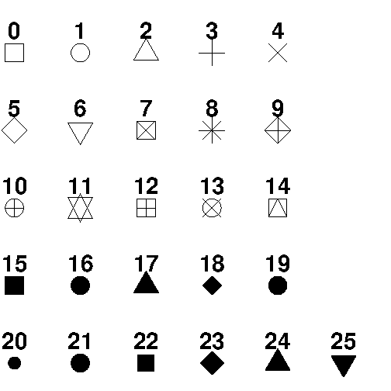
plot(1:10, col="red")

Use cex=number to change the size of the points (1 is default, while 0.5 means 50% smaller, and 2 means 100% larger):
plot(1:10, cex=2)

Point Shape pch=tal
Use pch with a value from 0 to 25 to change the point shape form

Line Width, Styles
change the width of the line, use the lwd parameter (1 is default, while 0.5 means 50% smaller, and 2 means 100% larger):
The line is solid by default. Use the lty parameter with a value from 0 to 6 to specify the line format.
For example, lty=3 will display a dotted line instead of a solid line:
Available parameter values for lty:
- 0 removes the line
- 1 displays a solid line
- 2 displays a dashed line
- 3 displays a dotted line
- 4 displays a "dot dashed" line
- 5 displays a "long dashed" line
- 6 displays a "two dashed" line

plot(1:10, type="l", lwd=2)

Multiple Lines
To display more than one line in a graph, use the plot() function together with the lines() function:
Example
line1 <- c(1,2,3,4,5,10)
line2 <- c(2,5,7,8,9,10) #undersforstået: x’erne er 1,2,.., såline2 har punkter (1,2), (2,5),..
plot(line1, type = "l", col = "blue")
lines(line2, type="l", col = "red")

Scatter Plots
You learned from the Plot chapter that the plot() function is used to plot numbers against each other.
A "scatter plot" is a type of plot used to display the relationship between two numerical variables, and plots one dot for each observation.
It needs two vectors of same length, one for the x-axis (horizontal) and one for the y-axis (vertical):
Example
x <- c(5,7,8,7,2,2,9,4,11,12,9,6)
y <- c(99,86,87,88,111,103,87,94,78,77,85,86)
plot(x, y)

Draw two plots on the same figure:
To compare the plot with another plot, use the points() function:
# day one, the age and speed of 12 cars:
x1 <- c(5,7,8,7,2,2,9,4,11,12,9,6)
y1 <- c(99,86,87,88,111,103,87,94,78,77,85,86)
# day two, the age and speed of 15 cars:
x2 <- c(2,2,8,1,15,8,12,9,7,3,11,4,7,14,12)
y2 <- c(100,105,84,105,90,99,90,95,94,100,79,112,91,80,85)
plot(x1, y1, main="Observation of Cars", xlab="Car age", ylab="Car speed", col="red", cex=2)
points(x2, y2, col="blue", cex=2)
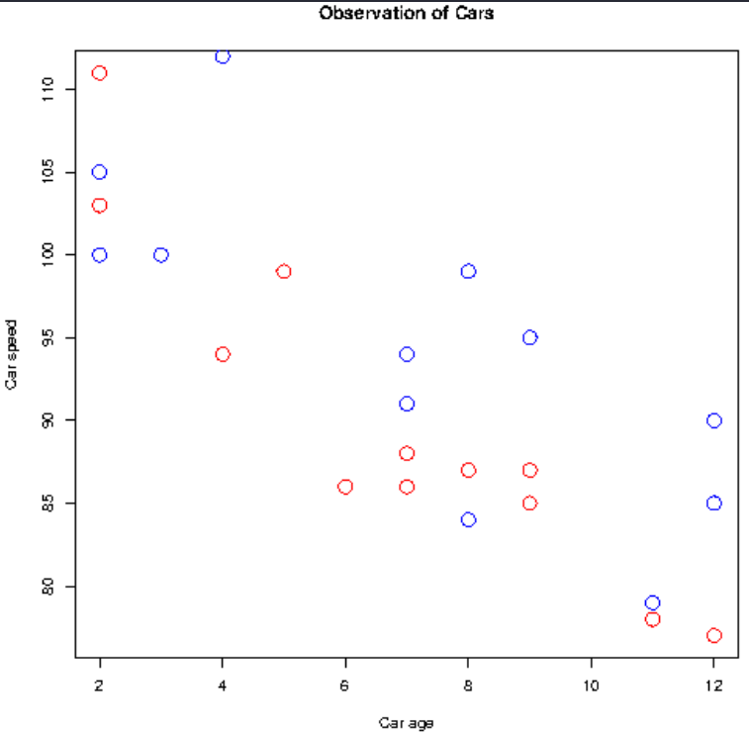

Plot with selected x- and y-interval
#define data
df <- data.frame(x=c(1, 3, 3, 4, 6, 8, 12, 13, 15, 18, 21, 22),
y=c(13, 15, 9, 17, 22, 25, 29, 35, 39, 44, 45, 40))

#create plot with default axis scales
plot(df$x, df$y, pch=19, main='Default Axes')

#create plot with custom axis scales
plot(df$x, df$y, pch=19, xlim=c(0,30), ylim=c(0,150), main='Custom Axes')
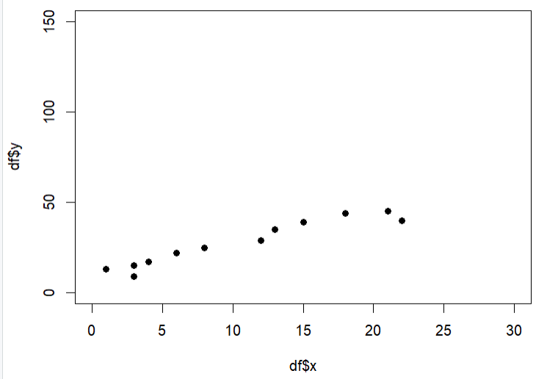

Pirateplot kan vise fordelingen over punkterne indenfor flere grupperinger
For example, here is a pirateplot height data from the pirates dataframe using theme = 3. Here, I’ll plot pirates’ heights as a function of their sex and whether or not they wear a headband. I’ll also make the plot all grayscale by using the pal = "gray" argument:
yarrr::pirateplot(formula = height ~ sex + headband, # DV = height, IV1 = sex, IV2 = headband
data = pirates,
theme = 3,
main = "Pirate Heights",
pal = "gray")
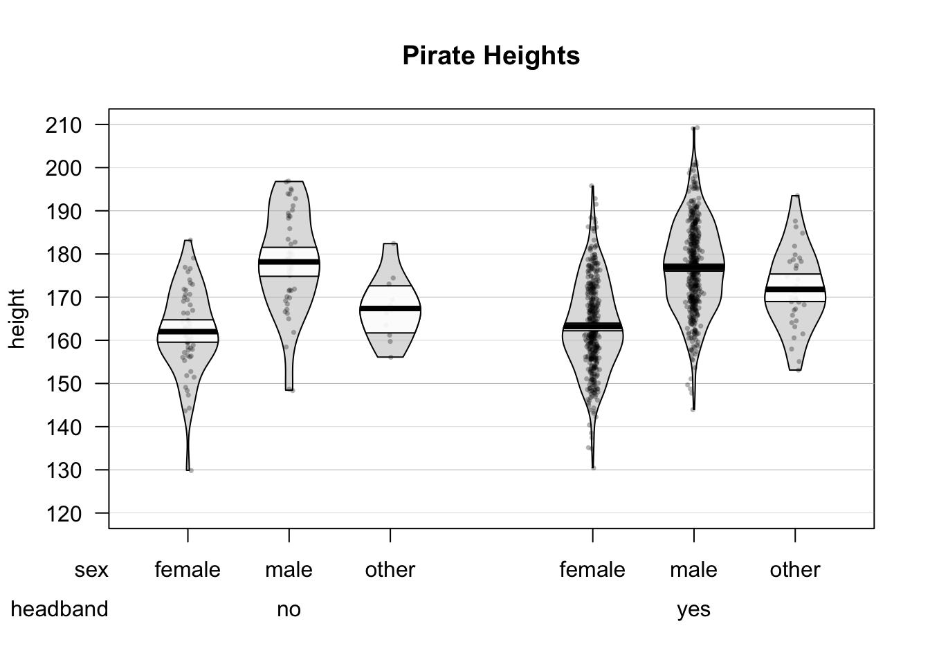

Pie chart
# Create a vector of pies
x <- c(10,20,30,40)
# Display the pie chart
pie(x)
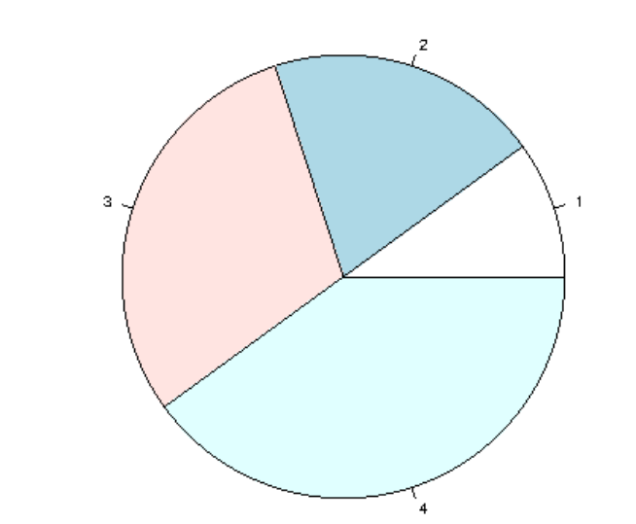

# Create a vector of pies
x <- c(10,20,30,40)
# Display the pie chart and start the first pie at 90 degrees
pie(x, init.angle = 90)

Pie chart med labels for ’lagkage-stykker’
# Create a vector of pies
x <- c(10,20,30,40)
# Create a vector of labels
mylabel <- c("Apples", "Bananas", "Cherries", "Dates")
# Display the pie chart with labels
pie(x, label = mylabel, main = "Fruits")

Selvvalgte farver
# Create a vector of pies
x <- c(10,20,30,40)
# Create a vector of colors
colors <- c("blue", "yellow", "green", "black")
mylabel <- c("Apples", "Bananas", "Cherries", "Dates")
# Display the pie chart with colors
pie(x, label = mylabel, main = "Fruits", col = colors)
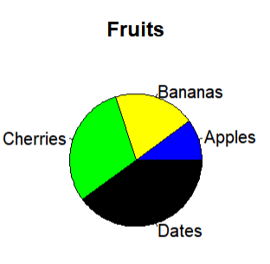

Legend
To add a list of explanation for each pie, use the legend() function:
Example
# Create a vector of labels
mylabel <- c("Apples", "Bananas", "Cherries", "Dates")
# Create a vector of colors
colors <- c("blue", "yellow", "green", "black")
# Display the pie chart with colors
pie(x, label = mylabel, main = "Pie Chart", col = colors)
# Display the explanation box
legend("bottomright", mylabel, fill = colors)
Result:
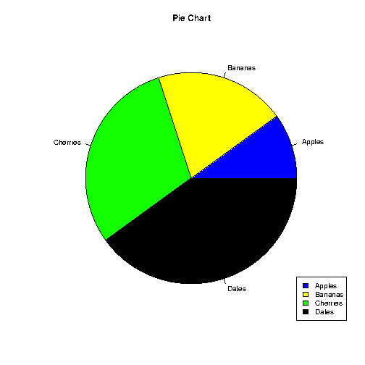
Try it Yourself »
The legend can be positioned as either:
bottomright, bottom, bottomleft, left, topleft, top, topright, right, center

Bar chart
# x-axis values
x <- c("A", "B", "C", "D")
# y-axis values
y <- c(2, 4, 6, 8)
barplot(y, names.arg = x)
barplot(y, names.arg = x, density = 10, col = "red")
barplot(y, names.arg = x, width = c(1,2,3,4))

Horizontal Bars
If you want the bars to be displayed horizontally instead of vertically, use horiz=TRUE:

x <- c("A", "B", "C", "D")
y <- c(2, 4, 6, 8)
barplot(y, names.arg = x, horiz = TRUE)

Histogram med automatisk optælling af hyppigheder i dataset: hist(dataframe$X)

*** Pivot-tabeller
datasets<-load("~/programmering/R/data/bhmtrains.rda")
datasets #bhmtrains
names(bhmtrains)
'[1] "ServiceId" "Status" "TOC"
[4] "TrainCategory" "PowerType" "SchedSpeedMPH" .. '

df<- bhmtrains
library(pivottabler)
pt <- PivotTable$new()
pt$addData(df )
pt$addColumnDataGroups("TrainCategory")
pt$addRowDataGroups("TOC")
#pt$defineCalculation(calculationName="Total", summariseExpression="n()") #antal rows
pt$defineCalculation(calculationName="Total%", summariseExpression="round(n()/nrow(df)*100,1)") # %
pt$renderPivot()
pt

TOC nedad Express Passenger Ordinary Passenger Total
Arriva Trains Wales 3079 830 3909
CrossCountry 22865 63 22928
London Midland 14487 33792 48279
Virgin Trains 8594 8594
Total 49025 34685 83710

*** Write , read CSV -filer

"C:\\Users\\bh\\Desktop\\data.csv” : path navn
1. Use write.csv from base R, for small files
If your data frame is reasonably small, you can just use the write.csv function from base R to export it to a CSV file.
When using this method, be sure to specify row.names=FALSE if you don’t want R to export the row names to the CSV file.
write.csv(df, "C:\\Users\\Bob\\Desktop\\data.csv", row.names=FALSE) eller write.csv(df, "data/data.csv", row.names=FALSE) hvor fil gemmes i /data i getwd()
write.csv(diamonds, "C:\\Users\\bh\\Documents\\programmering\\R\\data\\diamonds. csv", row.names=TRUE) ex
excelfilmappe: "C:\\Users\\bh\\Documents\\programmering\\Excel\\"
data<- "C:\\Users\\bh\\Documents\\programmering\\R\\data\\"
write.csv(df, "data/data.csv", row.names=FALSE) hvor fil gemmes i /data i getwd()

Read csv-file
df <- read.csv('/data/testfile.csv', sep=";")
df <- read.table(file='C:\\Users\\bob\\Desktop\\data.txt', header=FALSE, sep = "")
By default, the read.table function assumes there is no header row in the file and that the values are separated by white space.

df <- read.csv('https://github.com/CerebralMastication/R-Cookbook/tree/master/data/data1.csv’)
2. Use write_csv from reader package
An even faster way to export a data frame to a CSV file is with the write_csv function from the reader package. This is about 2x faster than write.csv and it never writes the row names from the data frame to a CSV file.
library(readr)
df<-read_csv(df, "data/diamonds.csv") #virker ikke

write_csv(df, "./data/test.csv")
write_csv(df, "C:\\Users\\Bob\\Desktop\\data.csv")

3. Use fwrite from data.table package
Yet a faster way (and a recommended method for large datasets) to export a data frame to a CSV file is with the fwrite function from the data.table package. This function is about 2x faster than the write_csv method.
library(data.table)
fwrite(df, "C:\\Users\\Bob\\Desktop\\data.csv")

Note that in each example we used double backslashes (\\) in the file path to avoid the following common error:
Error: '\U' used without hex digits in character string starting ""C:\U"
The Output
Each of the three methods above produce an identical CSV file. If we open this file with Excel, here’s what it looks like, ikke hos mig, men indenfra Excel kan data hentes under /Data/Extern fil

Read excel:
library(openxlsx)
df <- read.xlsx(xlsxFile = "./data/screening-alle-klasser-2020.xlsx")

write to working directory med openxlsx-library
Introduction (r-project.org)
library(openxlsx)
write.xlsx(df, 'my_data.xlsx')

## write a list of data.frames to individual worksheets using list names as
## worksheet names
l <- list(DF1 = df, DF2= df2)
write.xlsx(l, file = "writeXLSX2.xlsx") dataset skrives I to sheets/faner, DF1 og DF2 i filen writeXLSX2.xlsx

write og load rdata arkivfiler
save(df1, df2, file = "./myobjects.RData") #gemmer I getwd()
save.image(file = "./projectimage.RData") #save all objects in environment
ls() # viser objekterne i environment

load rdata - file og se indholdet
dataset<-load('./data/bad.rdata') # viser dataset i arkivet, loader data in i memory

dataset<-load('./data/bad.rdata' , ex <- new.env())
ls.str(ex)
x3 : num [1:40] -7.969 2.848 16.878 -10.304 0.197 ...
x4 : num [1:40] -3.9 -32.3 -12.2 37.3 14.2 ...
y2 : num [1:40] 654 26043 4831 35130 5025 ...
ex$y2
[1] 654.11911 26043.01840 4831.11062 35130.07352 5025.13398 37757.44819 …

**** Time-measurement of execution
#Forskel i sek
start.time <- Sys.time()
#...Relevent codes...
end.time <- Sys.time()
time.taken <- end.time - start.time
cat('time.taken[s]',time.taken )

#system.time I bruger, system, samlet
system.time( x <- matrix(data=NA,nrow=10000,ncol=10000) ) #10^8 elementer, fyldes medvNA=Null
bruger system forløbet
0.17 0.06 0.22
x <- matrix(data=NA,nrow=10000,ncol=10000) er koden der tidsmåles

**** Generate Test-Dateset
y <- rnorm(1000,5,1) # from N(5,1)
x<- rep(1, 1000) # 1'er, som class=1 i plot

df<-data.frame(x=x, class=y)
df

br<-c(seq(from=0, to=10, by=0.2))
br

hist(x = y,
main = "N(5,1), 1000 pkt",
xlab = "",
xlim = c(0, 10),
breaks=br
)
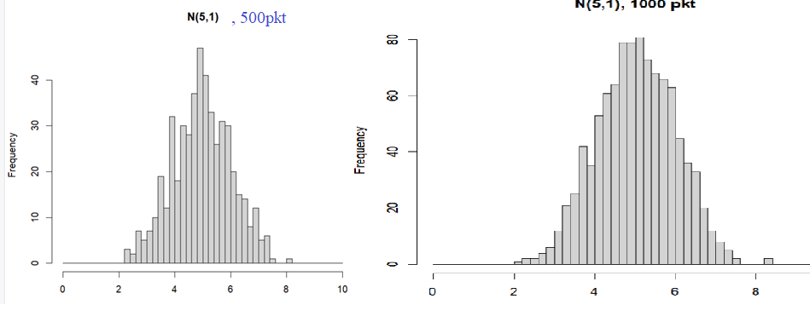
summary(df)
df %>%
summarise(
mean = mean(y),
sigma = sqrt(var(y)),
q1 = quantile(y,probs=c(0.25)),
q45 = quantile(y,probs=c(0.45)),
q50 = quantile(y,probs=c(0.50)),
q55 = quantile(y,probs=c(0.55)),
q3 = quantile(y,probs=c(0.75)),
N = n(),
)

**** Basal Statistik for dataset
Data Set

A data set is a collection of data, often presented in a table.
There is a popular built-in data set in R called "mtcars" (Motor Trend Car Road Tests), which is retrieved from the 1974 Motor Trend US Magazine.
In the examples below (and for the next chapters), we will use the mtcars data set, for statistical purposes:
Example
# Print the mtcars data set
mtcars

# Use the question mark to get meta-information about the data set
?mtcars

require(graphics)

pairs(mtcars, main = "mtcars data", gap = 1/4) giver oversigt med grafer over variable, parvist :
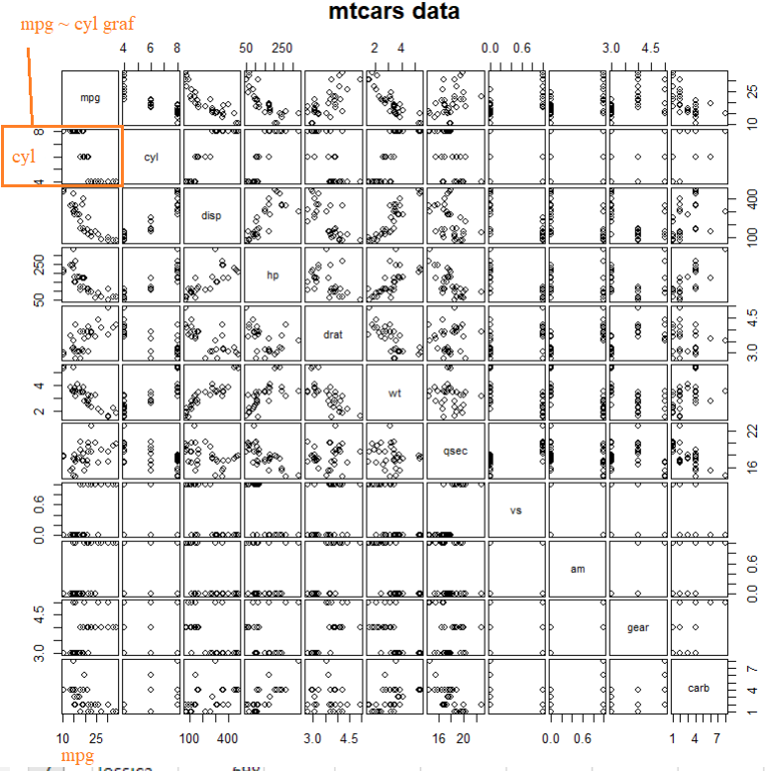
coplot(mpg ~ disp | as.factor(cyl), data = mtcars,
panel = panel.smooth, rows = 1) # | as.factor(cyl) givet/på baggrund af cyl-værdier, der inddeles efter disse
godt eksempel på brugen af factor, kategorial diskrete variable
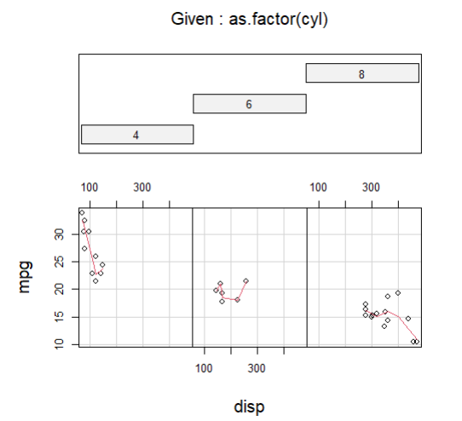alle gruppering vises i 1 row, nederst

summary(mtcars) #laver stat over alle tal-kolonner

## possibly more meaningful, e.g., for summary() or bivariate plots:
mtcars2 <- within(mtcars, {
vs <- factor(vs, labels = c("V", "S")) # "V" / "S" for 1/0 værdierne i vs-feltet
am <- factor(am, labels = c("automatic", "manual")) # "automatic" / "manual" for 1/0
cyl <- ordered(cyl) #hvad fkt har ordered ?
gear <- ordered(gear)
carb <- ordered(carb)
})
mtcars2
mpg cyl disp hp drat wt qsec vs am gear
Mazda RX4 21.0 6 160.0 110 3.90 2.620 16.46 V manual 4
Mazda RX4 Wag 21.0 6 160.0 110 3.90 2.875 17.02 V manual 4
Datsun 710 22.8 4 108.0 93 3.85 2.320 18.61 S manual 4
Hornet 4 Drive 21.4 6 258.0 110 3.08 3.215 19.44 S automatic 3
Hornet Sportabout 18.7 8 360.0 175 3.15 3.440 17.02 V automatic 3
Valiant 18.1 6 225.0 105 2.76 3.460 20.22 S automatic 3
Duster 360 14.3 8 360.0 245 3.21 3.570 15.84 V automatic 3
Merc 240D 24.4 4 146.7 62 3.69 3.190 20.00 S automatic 4
Merc 230 22.8 4 140.8 95 3.92 3.150 22.90 S automatic 4
Merc 280 19.2 6 167.6 123 3.92 3.440 18.30 S automatic 4
Merc 280C 17.8 6 167.6 123 3.92 3.440 18.90 S automatic 4
Merc 450SE 16.4 8 275.8 180 3.07 4.070 17.40 V automatic 3
Merc 450SL 17.3 8 275.8 180 3.07 3.730 17.60 V automatic 3
Merc 450SLC 15.2 8 275.8 180 3.07 3.780 18.00 V automatic 3
Cadillac Fleetwood 10.4 8 472.0 205 2.93 5.250 17.98 V automatic 3
Lincoln Continental 10.4 8 460.0 215 3.00 5.424 17.82 V automatic 3
Chrysler Imperial 14.7 8 440.0 230 3.23 5.345 17.42 V automatic 3
Fiat 128 32.4 4 78.7 66 4.08 2.200 19.47 S manual 4
Honda Civic 30.4 4 75.7 52 4.93 1.615 18.52 S manual 4
Toyota Corolla 33.9 4 71.1 65 4.22 1.835 19.90 S manual 4
Toyota Corona 21.5 4 120.1 97 3.70 2.465 20.01 S automatic 3
Dodge Challenger 15.5 8 318.0 150 2.76 3.520 16.87 V automatic 3
AMC Javelin 15.2 8 304.0 150 3.15 3.435 17.30 V automatic 3
Camaro Z28 13.3 8 350.0 245 3.73 3.840 15.41 V automatic 3
Pontiac Firebird 19.2 8 400.0 175 3.08 3.845 17.05 V automatic 3
Fiat X1-9 27.3 4 79.0 66 4.08 1.935 18.90 S manual 4
Porsche 914-2 26.0 4 120.3 91 4.43 2.140 16.70 V manual 5
Lotus Europa 30.4 4 95.1 113 3.77 1.513 16.90 S manual 5
Ford Pantera L 15.8 8 351.0 264 4.22 3.170 14.50 V manual 5
Ferrari Dino 19.7 6 145.0 175 3.62 2.770 15.50 V manual 5
Maserati Bora 15.0 8 301.0 335 3.54 3.570 14.60 V manual 5
Volvo 142E 21.4 4 121.0 109 4.11 2.780 18.60 S manual 4
carb
Mazda RX4 4
Mazda RX4 Wag 4
Datsun 710 1
Hornet 4 Drive 1
Hornet Sportabout 2
Valiant 1
Duster 360 4
Merc 240D 2
Merc 230 2
Merc 280 4
Merc 280C 4
Merc 450SE 3
Merc 450SL 3
Merc 450SLC 3
Cadillac Fleetwood 4
Lincoln Continental 4
Chrysler Imperial 4
Fiat 128 1
Honda Civic 2
Toyota Corolla 1
Toyota Corona 1
Dodge Challenger 2
AMC Javelin 2
Camaro Z28 4
Pontiac Firebird 2
Fiat X1-9 1
Porsche 914-2 2
Lotus Europa 2
Ford Pantera L 4
Ferrari Dino 6
Maserati Bora 8
Volvo 142E 2

Data_Cars <- mtcars # create a variable of the mtcars data set for better organization
>
> # Use dim() to find the dimension of the data set

dim(Data_Cars) # rows columns
[1] 32 11
From the examples above, we have found out that the data set has 32 observations (Mazda RX4, Mazda RX4 Wag, Datsun 710, etc) and 11 variables (mpg, cyl, disp, etc).
>
> # Use names() to find the names of the variables from the data set, column-names, rownames vises ikke

names(Data_Cars)
[1] "mpg" "cyl" "disp" "hp" "drat" "wt" "qsec" "vs" "am" "gear"
[11] "carb"

rownames(Data_Cars) #giver indexværdierne , her bilnavne

Data_Cars$cyl #cyl-kolonnen

To sort the values, use the sort() function:
sort(Data_Cars$cyl)

Max, Min, max(df$X) giver max-vardi for X-kolonnen; df[ which.max(df$X) ] giver datarække med max-værdien

Data_Cars <- mtcars
which.max(Data_Cars$hp) #row nr for max,
which.min(Data_Cars$hp)

rownames(Data_Cars)[ which.max(Data_Cars$hp) ] [1] "Maserati Bora"
rownames(Data_Cars)[which.min(Data_Cars$hp)]

in statistics, there are often three values that interests us:
- Mean - The average value
- Median - The middle value
- Mode - The most common value, typetallet
mean(Data_Cars$wt) #middel af wt-værdierne

ordered_hp<- Data_Cars[order(Data_Cars$hp),] # ordered I voksende rækkeflg
ordered_hp

sort(table(Data_Cars$disp)) #frekvenser angives i voksende rækkeflg
71.1 75.7 78.7 79 95.1 108 120.1 120.3 121 140.8
1 1 1 1 1 1 1 1 1 1
145 146.7 225 258 301 304 318 350 351 400
1 1 1 1 1 1 1 1 1 1
440 460 472 160 167.6 360 275.8
1 1 1 2 2 2 3

names( sort(-table(Data_Cars$wt)) )[1] # sort(-table(Data_Cars$wt)) giver kolonne med sortering i modsat retning, øverst
table(Data_Cars$wt) laver table med een kolonne

Percentiles/kvartiler for kolonne-værdier

# c() specifies which percentile you want
quantile(Data_Cars$wt, c(0.75)) # her altså 75% percentilen, øvre median, meaning that 75% or the cars weight 3 610 lbs or les
75%
3.61

quantile(Data_Cars$wt) # 0, 25, 50, 75 and 100 percentiler

